**Healthcare predictive Analysis project**

Capstone project for the second cohort of the Digital Egypt Initiative, under the auspices of the Ministry of Communications and Information Technology

**Data Science Track**

**Project Team Member:**

* Mai Mosaad Ragab
* Somia Ashraf Soliman elsaed
* Nada Ragab Ibrahim
* Maha Mosbeh Elkohaley
* Aisha Tarek abdelhamid
* gehad abdelal

***Under Supervision of***

**Dr. Eslam Elreedy**

Acknowledgment

As we reflect on the completion of this project, it is important to recognize the collective efforts that have made this dataset and its analysis possible. The journey of cleaning, analyzing, and preparing the Diabetic Data Cleaning dataset for predictive modeling has been both challenging and rewarding. It is through the dedication and support of various individuals and organizations that this work has reached its current stage.

First and foremost, we extend our deepest gratitude to the original creators of the dataset, whose efforts in compiling and sharing this valuable resource have enabled researchers and data scientists to explore critical healthcare challenges, such as predicting hospital readmissions for diabetic patients. The dataset, sourced from Kaggle (Diabetic Data Cleaning Dataset), is a testament to the importance of open data in advancing medical research and improving patient outcomes.

We would also like to acknowledge the contributions of the healthcare institutions and professionals who originally collected and anonymized the patient data. Their commitment to ethical data practices and patient privacy has ensured that this dataset can be used responsibly for research purposes.

Special thanks go to the data science community, whose collaborative spirit and shared knowledge have been instrumental in refining the techniques and methodologies applied in this project. The guidance and insights from peers, mentors, and online resources have been invaluable in overcoming the technical challenges encountered during the data cleaning and analysis process.

In particular, we are grateful to Dr. Eslam Elreedy, whose expertise and mentorship have been a guiding light throughout this project. His dedication to fostering a deeper understanding of data science principles and his unwavering support have not only contributed to the success of this work but have also inspired growth and learning beyond the scope of this dataset.

Additionally, we appreciate the support of our colleagues and fellow researchers, who have provided constructive feedback and encouragement. Their contributions, whether through direct collaboration or shared resources, have enriched this project and broadened its potential impact.

Finally, we are thankful for the opportunity to work with this dataset and contribute to the ongoing efforts to improve healthcare outcomes through data-driven insights. The knowledge and experience gained from this project will undoubtedly serve as a foundation for future endeavors in the field of medical data analysis.

As we conclude this phase of the project, we do so with a sense of pride and accomplishment, knowing that the work done here has the potential to make a meaningful difference. We look forward to the next steps, including the development of predictive models and further exploration of the data, with the hope of contributing to advancements in patient care and hospital management.

Congratulations to all who have been part of this journey—we did it!

**DECLARATION**

We hereby certify that this material, which we now submit for assessment on the program of the Data Science Track, is entirely our own work. We have exercised reasonable care to ensure that the work is original and, to the best of our knowledge, does not breach any law of copyright. Any work or ideas taken from external sources have been properly cited and acknowledged within the text of our work. This declaration applies to all aspects of the project, including the cleaning, analysis, and documentation of the Diabetic Data Cleaning dataset.

**Signed:** \_\_\_\_\_\_\_\_\_\_\_\_\_\_\_\_\_\_\_\_\_\_\_\_\_\_\_\_\_  
**Date:** April 29, 2025

**ABSTRACT**

The Diabetic Data Cleaning dataset, accessible via Kaggle and sourced from the UCI Machine Learning Repository, comprises a rigorously curated and preprocessed collection of diabetic patient records, optimized for advanced healthcare analytics and machine learning applications. Preprocessing entailed meticulous imputation of missing values, encoding of categorical variables, and validation of data consistency to ensure analytical integrity. The dataset includes critical patient attributes—demographics, medical histories, and readmission outcomes—rendering it an essential tool for predictive modeling of patient outcomes, exploration of health determinants, and statistical assessment of diabetic care practices. This resource empowers data-driven advancements in patient care and healthcare system efficiency.

The dataset's utility is further underscored by its comprehensive feature set, which includes patient demographics (age, gender, race), medical history (diagnosis codes, number of medications), and hospital admission details (admission type, time in hospital, number of lab procedures). The primary outcome variable, readmission status, is pivotal for developing models that predict patient readmissions, thereby enabling healthcare providers to implement targeted interventions and reduce readmission rates. Additional attributes, such as the number of emergency visits and outpatient encounters, enhance the dataset’s capacity to support longitudinal studies of patient health trajectories. Designed for versatility, it accommodates a range of analytical approaches, from statistical inference to deep learning, fostering innovation in healthcare research. This dataset is a critical asset for researchers, data scientists, and healthcare professionals aiming to leverage data-driven insights for improved patient outcomes and healthcare system efficiency.

Table of ContentS

## **1. Introduction**

### 1.1 Problem definition

### 1.2 Solution

### 1.3 Scope

## **2. Dataset Overview**

### **2.1 Source**

### **2.2 Feature Definitions**

## **3. Methodology**

### **3.1 Importing Libraries**

### **3.2 Loading the Dataset**

## **4. Exploratory Data Analysis (EDA)**

### **4.1 Descriptive Statistics**

### **4.2 Univariate Analysis**

### **4.3 Multivariate Analysis**

### **4.4 Interactive Visualizations**

## **5. Data Preprocessing and Cleaning**

### **5.1 Handling Missing Data**

### **5.2 Handling Invalid Entries**

### **5.3 Data Type Conversion**

### **5.4 Handling Outliers**

### **5.5 Encoding Categorical Variables**

### 5.6 Grouping Columns

### 5.7 Target Variable Transformation

## **6. Scaling**

### **6.1. Saving Cleaned Data**

## **7. Summary of Preprocessing Steps**

### **7.1 Key Observations**

## **8. Machine Learning Models for Hospital Readmission Prediction**

### 8.1

### 8.2 Data Description

### **8.3**

#### 8.3.1 Train-Test Split

#### 8.3.2 Standardization

#### 8.3.3 Model Training and Evaluation

### 8.4 Evaluation Metrics

### **8.5 Class Imbalance Mitigation**

#### 8.5.1 Class Weighting

#### 8.5.2 SMOTE and SMOTE-Tomek

#### 8.5.3 Impact of Imbalance Mitigation

### 8.6 Combined Models with SMOTE

### 8.7 Combined Models with SMOTE-Tomek

### 8.8 Hyperparameter Tuning

### **8.9 Hyperparameter Tuning Overview**

#### 8.9.1 Methods for Hyperparameter Tuning

#### 8.9.2 Role of Cross-Validation

### 8.10 Examples of Tuned Models

### 8.11 Model Saving:

### **8.12 Neural Network Experiments**

#### 8.12.1 Comparison

### 8.13 Concluding Remarks on Model Improvement

## **9. Model Selection and Comparison**

### 9.1 Summary of Model Performances

### 9.2 Key Observations

## **10.1 Characteristics of Models in the Readmission Prediction Project**

### **1. Setting Up MLflow Experiment**

### **2. Training and Logging Models**

### **3. Tracking Models with MLflow**

### **4. Main Function for Running All Models**

### **5. Accessing the MLflow UI**

### 6. Building the FastAPI Application

## **11. Conclusion and Future Work**

#### 11.1 Summary of Findings

#### 11.2 Limitations

#### 11.3 Future Work

# 

# **INTRODUCTION AND BACKGROUND**

## **1.Introduction**

In the complex and evolving landscape of healthcare, where patient outcomes intersect with operational challenges, hospitals face significant issues related to patient readmissions, particularly among diabetic patients. At the forefront of these concerns is the high rate of hospital readmissions, which not only impacts patient health but also places substantial financial and operational burdens on healthcare systems. The Diabetic Data Cleaning dataset, sourced from Kaggle ([Diabetic Data Cleaning Dataset](https://www.kaggle.com/datasets/smit1212/diabetic-data-cleaning" \t "_blank)), provides a comprehensive collection of 101,766 patient encounters, capturing demographic, medical, and administrative data to address these challenges.

Recognizing the urgency of improving patient care and reducing readmissions, our project introduces a robust data-driven approach to clean, preprocess, and analyze this dataset. This comprehensive document delves into the intricacies of our methodology, offering a detailed exploration of data cleaning techniques, exploratory data analysis, feature engineering, and the preparation of the dataset for predictive modeling. Our initiative leverages advanced data science techniques to uncover insights and develop solutions that enhance healthcare delivery.

The core objective of this project is to address the root causes of hospital readmissions by harnessing the power of data analytics. Through a thorough understanding of the dataset’s complexities, our work aims to create a foundation for predictive models that can identify at-risk patients, thereby reducing readmission rates and improving patient outcomes. This introduction serves as a prelude to a deeper examination of our commitment to advancing healthcare through data-driven innovation, specifically tailored to the unique challenges posed by diabetic patient care.

### **1.1 Problem definition**

Healthcare systems worldwide face critical challenges in managing hospital readmissions, particularly for diabetic patients. Two primary issues dominate this landscape, significantly impacting patient well-being and healthcare efficiency. Firstly, the high prevalence of readmissions, especially within 30 days of discharge, poses a severe threat to patient health, leading to prolonged recovery times and increased medical costs. These readmissions often stem from complex factors, including inadequate post-discharge care, comorbidities, and medication non-adherence. Secondly, the variability and incompleteness of patient data exacerbate the challenge of identifying at-risk individuals. Missing values, inconsistent formats, and high-dimensional data in the Diabetic Data Cleaning dataset hinder accurate analysis and prediction, necessitating robust data cleaning and preprocessing strategies.

The implications of these challenges extend beyond patient care, contributing to financial strain on healthcare systems through penalties for high readmission rates and increased resource utilization. The urgency of addressing these issues underscores the need for an effective, data-driven intervention to improve patient outcomes and optimize hospital operations.

### **1.2 Solution**

Our proposed solution is a comprehensive and innovative approach to tackling the challenges of hospital readmissions using the Diabetic Data Cleaning dataset. By leveraging advanced data science techniques, this solution integrates robust data cleaning, exploratory analysis, and feature engineering into a cohesive workflow, preparing the dataset for predictive modeling. Key components of the solution include:

* **Data Cleaning and Preprocessing**:  
  We address missing values (e.g., in weight, max\_glu\_serum, and A1Cresult) by imputing with appropriate placeholders (e.g., "No Test") or the mode for categorical features. Outliers in numerical columns like num\_lab\_procedures are mitigated through imputation or transformation, ensuring data consistency. Categorical variables (e.g., gender, race) are converted to appropriate types, and irrelevant columns like weight are dropped to streamline analysis.
* **Exploratory Data Analysis (EDA)**:  
  Through univariate and bivariate analyses, we uncover patterns in the dataset, such as the positive correlation between num\_lab\_procedures and time\_in\_hospital, indicating that complex cases require more tests and longer stays. The distribution of readmitted highlights class imbalance, guiding model development strategies.
* **Feature Engineering and Transformation**:  
  We create new features, such as time\_diagnoses\_interaction (multiplying time\_in\_hospital and number\_diagnoses), to capture combined effects. Numerical features are normalized using MinMaxScaler, and categorical variables are one-hot encoded to ensure compatibility with machine learning algorithms. The readmitted column is encoded as {NO: 0, >30: 1, <30: 2} to facilitate modeling.

This solution prepares a clean, structured dataset ready for predictive modeling to identify factors contributing to readmissions. By addressing data quality issues and extracting meaningful insights, our approach lays the groundwork for developing models that can reduce readmission rates and improve patient care.

### **1.3 Scope**

The scope of the problem is extensive, affecting various aspects of healthcare and requiring a multifaceted approach to address effectively. Key dimensions include:

* **Patient Outcomes**: High readmission rates, particularly within 30 days, compromise patient health and recovery. The scope encompasses identifying risk factors and improving post-discharge care to enhance outcomes.
* **Data Quality**: Incomplete and inconsistent data (e.g., missing values in A1Cresult, high-dimensional diagnosis codes) pose significant challenges. The scope includes developing robust cleaning and preprocessing techniques to ensure data reliability.
* **Healthcare Efficiency**: Readmissions strain hospital resources and incur financial penalties. The scope involves optimizing resource allocation through predictive models that identify at-risk patients.
* **Public Health**: Frequent readmissions contribute to broader public health challenges, including increased morbidity among diabetic patients. The scope encompasses reducing these impacts through data-driven interventions.
* **Economic Impact**: The financial burden of readmissions includes healthcare costs, penalties, and lost productivity. The scope involves mitigating these costs through improved patient management.
* **Technology and Innovation**: Addressing readmissions requires advancements in data science and machine learning. The scope includes the development and application of analytical tools to transform raw data into actionable insights.

By focusing on these dimensions, our project aims to contribute to a safer, more efficient healthcare system through the rigorous analysis of the Diabetic Data Cleaning dataset.

**2)** **Data Cleaning and Preprocessing**

## **2. Dataset Overview**

### **2.1Source:**

### The dataset, sourced from Kaggle ([Diabetic Data Cleaning Dataset](https://www.kaggle.com/datasets/smit1212/diabetic-data-cleaning" \t "_blank)), originates from hospital records of diabetic patient encounters, likely inspired by the "Diabetes 130 US Hospitals" dataset (1999–2008). It comprises 101,766 patient encounters with 50 features, capturing demographic, medical, and administrative details to facilitate analysis of hospital readmissions.

### **2.2 Feature Definitions:**

The dataset includes a diverse set of features, each providing critical insights into patient profiles and hospital interactions. Below is a summary of key features:

|  |  |
| --- | --- |
| **Feature Name** | **Description** |
| encounter\_id | Unique ID for each patient visit. |
| patient\_nbr | Unique ID for each patient (multiple visits). |
| race | Patient's race (e.g., Caucasian, African-American). |
| gender | Patient's gender (Male/Female). |
| age | Age group (e.g., [0-10), [10-20), etc.). |
| weight | Patient's weight (in lbs). |
| admission\_type\_id | Type of admission (e.g., emergency, elective). |
| discharge\_disposition\_id | Discharge method (e.g., discharged to home). |
| admission\_source\_id | Admission source (e.g., referral, self-admitted). |
| time\_in\_hospital | Length of stay in days. |
| num\_lab\_procedures | Number of lab tests performed. |
| num\_medications | Number of medications prescribed. |
| number\_outpatient | Number of outpatient visits. |
| number\_emergency | Number of emergency visits. |
| number\_inpatient | Number of inpatient visits. |
| diag\_1, diag\_2, diag\_3 | ICD-9 diagnosis codes. |
| number\_diagnoses | Total number of diagnoses during the visit |
| max\_glu\_serum | Maximum glucose serum measurement (None, Norm, >200, >300). |
| A1Cresult | HbA1c test result (None, Norm, >7, >8). |
| change | Whether medication was changed (Yes/No). |
| diabetesMed | Whether the patient is on diabetes medication (Yes/No). |
| readmitted | Readmission status (<30, >30, NO). |
| payer\_code | A code indicating the payer for the hospital visit (e.g., Medicare, private insurance, self-pay, etc.). |
| medical\_specialty | The specialty of the attending physician (e.g., Cardiology, InternalMedicine, Surgery-General, etc.). |
| num\_procedures | The number of non-laboratory procedures (e.g., surgeries, imaging) performed during the hospital stay. |
| metformin | The status of metformin medication (e.g., "No", "Steady", "Up", "Down"). |
| repaglinide | The status of repaglinide medication. |
| nateglinide | The status of nateglinide medication. |
| chlorpropamide | The status of chlorpropamide medication. |
| glimepiride | The status of glimepiride medication. |
| acetohexamide | The status of acetohexamide medication. |
| glipizide | The status of glipizide medication. |
| glyburide | The status of glyburide medication. |
| tolbutamide | The status of tolbutamide medication. |
| pioglitazone | The status of pioglitazone medication. |
| rosiglitazone | The status of rosiglitazone medication. |
| acarbose | The status of acarbose medication. |
| miglitol | The status of miglitol medication. |
| troglitazone | The status of troglitazone medication. |
| tolazamide | The status of tolazamide medication. |
| examide | The status of examide medication. |
| citoglipton | The status of citoglipton medication. |
| insulin | The status of insulin medication. |
| glyburide-metformin | The status of glyburide-metformin combination medication. |
| glipizide-metformin | The status of glipizide-metformin combination medication. |
| glimepiride-pioglitazone | The status of glimepiride-pioglitazone combination medication. |
| metformin-rosiglitazone | The status of metformin-rosiglitazone combination medication. |
| metformin-pioglitazone | The status of metformin-pioglitazone combination medication. |

## 

**2.3 Data Characteristics:**

* **Size**: 101,766 rows, 50 columns
* **Data Types:**

1. **Numerical:**
   * **11 integer columns** (e.g., encounter\_id, admission\_type\_id, number\_inpatient)
   * **4 float columns** (e.g., age, num\_medications, num\_lab\_procedures)
2. **Categorical:**
   * **33 object (string) columns** (e.g., race, gender, diag\_1)

* **Target Variable**:
  + Identifiers: encounter\_id, patient\_nbr
  + Demographics: race, gender, age
  + Medical: num\_lab\_procedures, num\_medications, diag\_1, diag\_2, diag\_3, etc.
  + Target:
  + The main outcome of interest is **readmitted**, which indicates whether the patient was readmitted after discharge. It is also encoded as **encoded\_readmitted** for predictive modeling purposes.

## **3. Methodology**

The preprocessing and analysis workflow was designed to ensure data quality and suitability for modeling. The key steps are outlined below:

### **3.1 Importing Libraries**

To facilitate data manipulation, visualization, and preprocessing, the following Python libraries were utilized:

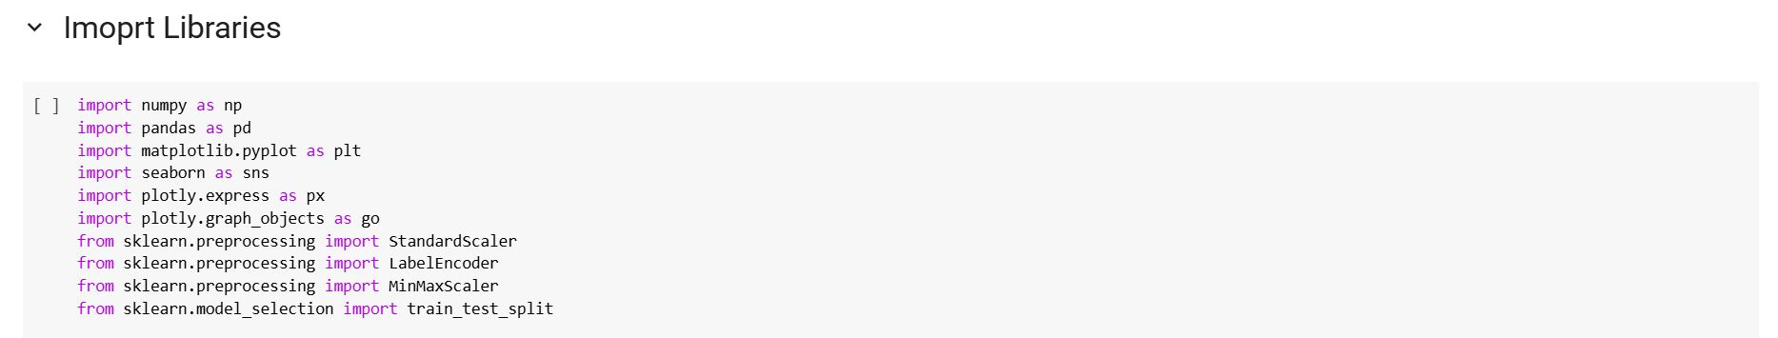

To enable efficient data processing, visualization, and preparation for machine learning tasks, several Python libraries were employed in this project:

* **NumPy (numpy)**: Used for numerical computations, especially when working with arrays and performing mathematical operations efficiently.
* **Pandas (pandas)**: Essential for data manipulation and analysis, particularly with tabular data structures such as DataFrames.
* **Matplotlib (matplotlib.pyplot)**: Utilized for generating static visualizations such as line plots, bar charts, and histograms.
* **Seaborn (seaborn)**: Built on top of Matplotlib, it provides more advanced statistical visualizations with enhanced aesthetics and simplified syntax.
* **Plotly Express (plotly.express)**: A high-level interface for creating interactive and responsive visualizations with minimal code.
* **Plotly Graph Objects (plotly.graph\_objects)**: A more detailed and customizable way to create interactive plots, allowing full control over plot components.
* **StandardScaler (sklearn.preprocessing.StandardScaler)**: Applied to standardize features by removing the mean and scaling to unit variance, which is crucial for many machine learning algorithms.
* **LabelEncoder (sklearn.preprocessing.LabelEncoder)**: Used to convert categorical string labels into numerical format, making them suitable for model training.
* **MinMaxScaler (sklearn.preprocessing.MinMaxScaler)**: Scales features to a specified range, typically between 0 and 1, which helps normalize data for certain algorithms.
* **Train-Test Split (sklearn.model\_selection.train\_test\_split)**: Used to divide the dataset into training and testing sets, ensuring proper model evaluation and generalization.

These libraries collectively provide a comprehensive toolkit for handling numerical operations, structured data manipulation, creating both static and interactive visualizations, and preparing features for machine learning models.

### **3.2 Loading the Dataset**

The dataset was loaded from its source and inspected to understand its structure:

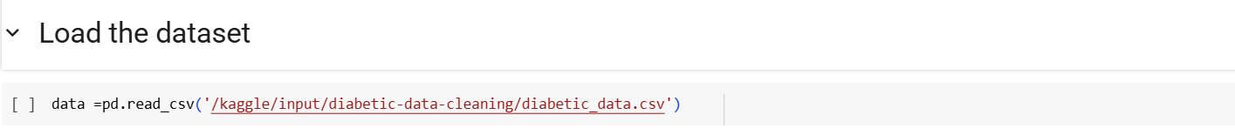

**In this step, the dataset is loaded into a Pandas DataFrame using the read\_csv() function.**  
The file path '/kaggle/input/diabetic-data-cleaning/diabetic\_data.csv' points to the CSV file containing the dataset. This allows for structured data manipulation and analysis using the powerful functionalities of the Pandas library.

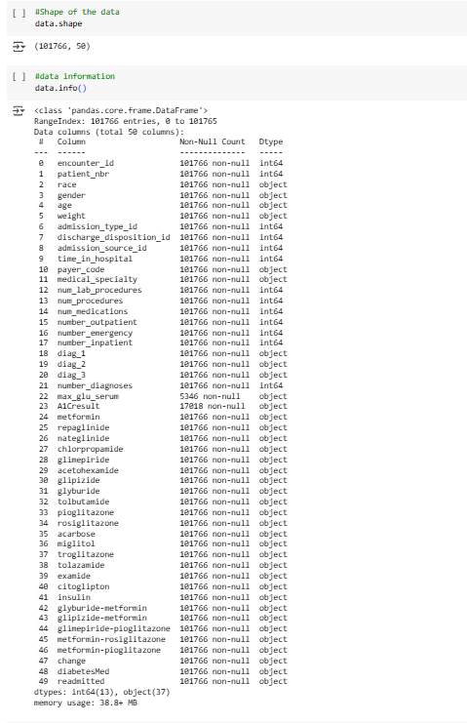

**This step provides an overview of the dataset's structure and basic metadata.**  
The output of data.shape reveals that the dataset consists of **101,766 rows** and **50 columns**, indicating a large and feature-rich dataset suitable for analysis and modeling.

The data.info() function displays detailed information about each column, including the number of non-null entries and their data types. The dataset includes both numerical and categorical variables, with 13 columns of type int64 and 37 of type object. This highlights the need for appropriate preprocessing steps, such as handling missing values, encoding categorical features, and scaling numerical values before training machine learning models.

Additionally, some columns, such as max\_glu\_serum and A1Cresult, contain missing or sparse data, which may require special treatment during data cleaning.

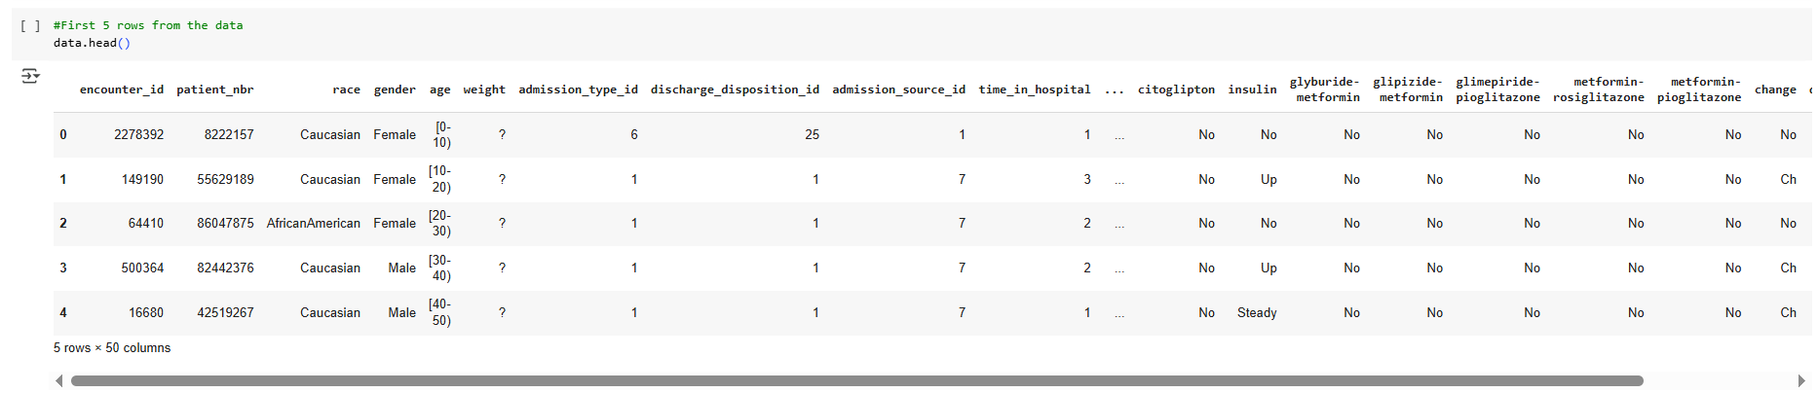

This step in understanding the dataset is to examine its structure, which includes the number of rows and columns, as well as identifying the feature names and the associated data types for each column.

An initial inspection of the data reveals some issues, such as missing values in columns like "weight" and potential inconsistencies in categorical encoding. For example, categorical data appears both as text (e.g., "Male", "Female") and as intervals (e.g., "[0-10]" for age). These inconsistencies and missing values need to be addressed to ensure data quality and integrity during the preprocessing phase.

To get a better sense of the data, we use the data.head() function, which displays the first five rows of the dataset. This preview provides a snapshot of the structure, allowing us to inspect sample records, column names, and the general formatting of the data. It helps us identify irregularities such as missing values (represented by "?") and inconsistencies in categorical representations.

Initial inspection revealed missing values (e.g., in weight, max\_glu\_serum) and a mix of numerical and categorical features, necessitating comprehensive preprocessing.

## **4. Exploratory Data Analysis (EDA):**

Exploratory Data Analysis was conducted to uncover patterns, distributions, and relationships within the dataset, guiding subsequent preprocessing and modeling efforts.

### **4.1 Descriptive Statistics**

* **Numerical Features**: Summarized using mean, median, and standard deviation to understand central tendencies and variability. For example, num\_lab\_procedures and time\_in\_hospital were analyzed to assess typical patient testing and stay durations.
* **Missing Values**: Quantified per column to identify data quality issues, with weight showing a high percentage of missing entries (marked as ?) and max\_glu\_serum and A1Cresult having significant "None" values.

### **4.2 Univariate Analysis**

* **Box Plots**: Generated for numerical variables (e.g., num\_lab\_procedures, num\_medications) to inspect distributions and detect outliers. These plots revealed that num\_lab\_procedures had a skewed distribution with some extreme values, indicating potential outliers.

**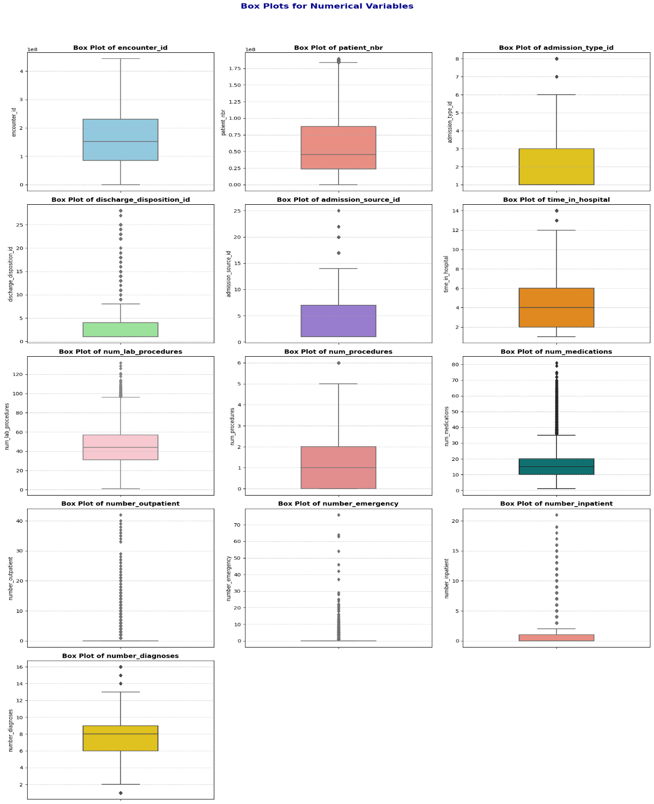**

### **4.3 Multivariate Analysis**

* **Count Plots and Bar Charts**: Created for categorical features (e.g., race, gender, readmitted) to examine their distributions relative to readmission status. For instance, count plots showed that the "NO" category in readmitted was predominant, indicating class imbalance.

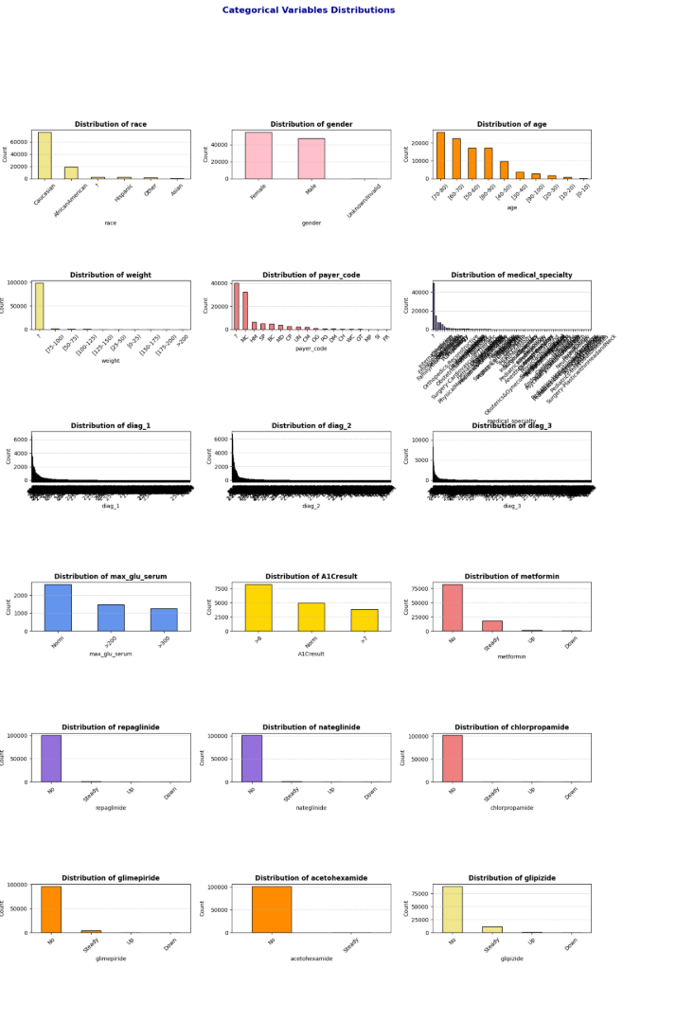 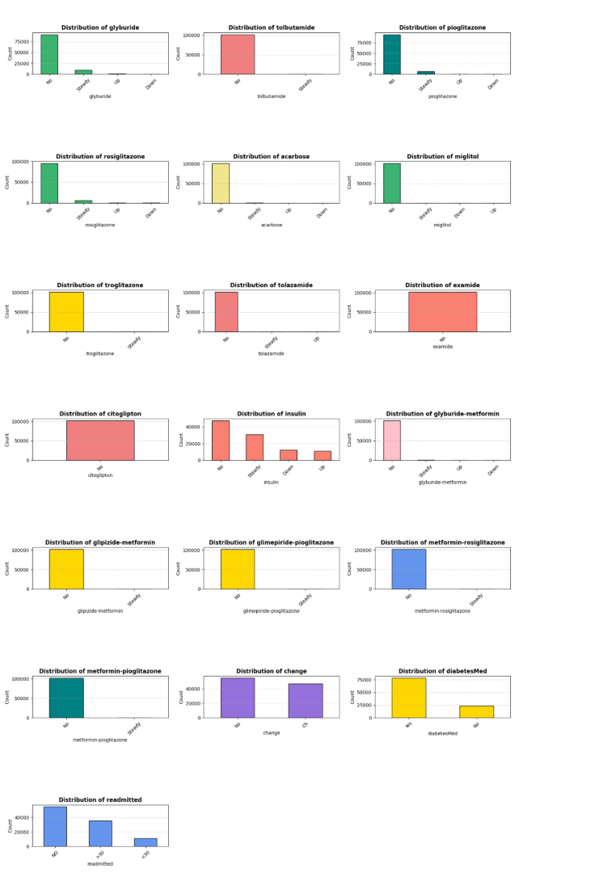

### **4.4 Interactive Visualizations**

Interactive visualizations were developed using Plotly to provide dynamic insights:

* **Bar Chart**: Illustrated the distribution of patients by race and weight, grouped by gender. Due to missing weight data, this visualization was limited but highlighted demographic patterns:

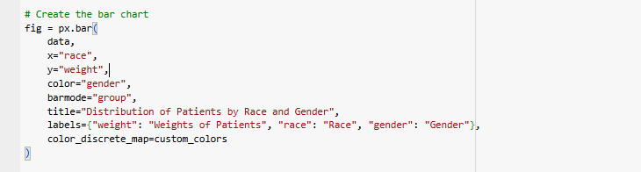

An interactive bar chart of race and weight by gender:

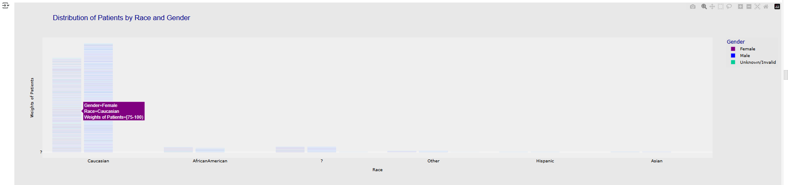

* **Bubble Chart**: Visualized readmitted against num\_lab\_procedures, with bubble size representing time\_in\_hospital. This chart revealed that patients with more lab procedures and longer hospital stays were more likely to be readmitted.

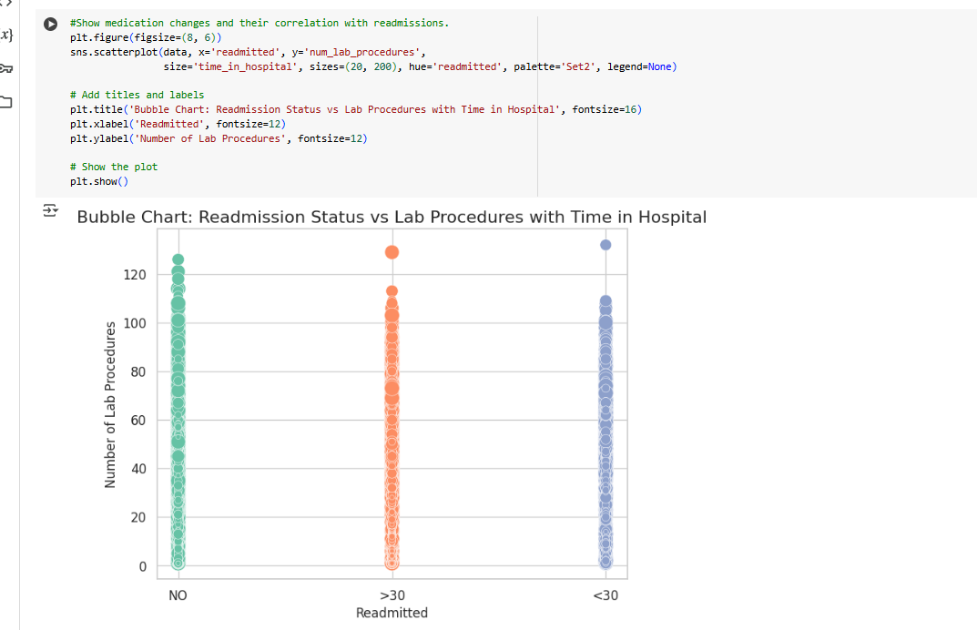

These analyses highlighted key patterns, such as the correlation between num\_lab\_procedures and time\_in\_hospital, and the imbalanced nature of readmitted, informing preprocessing strategies.

## **5. Data Preprocessing and Cleaning**

To ensure the dataset’s quality and usability for analysis and predictive modeling, a rigorous cleaning and preprocessing pipeline was implemented. The following steps addressed missing values, invalid entries, data types, outliers, and feature transformations:

### **5.1 Handling Missing Data**

* A heatmap was used to visualize missingness across the dataset, confirming high missing values in weight and partial missingness in max\_glu\_serum and A1Cresult:

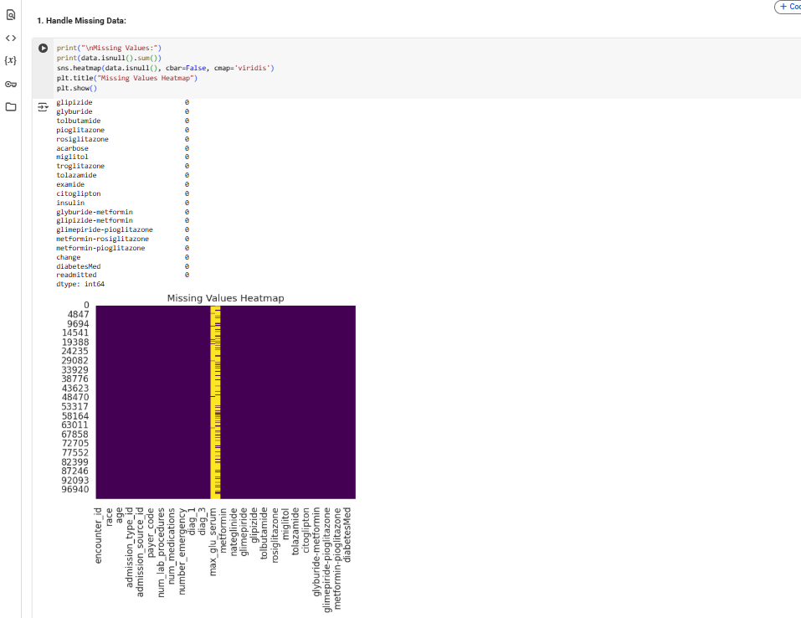

* **Max Glu Serum & A1Cresult**: Missing values were imputed with "No Test" to indicate no testing occurred(which preserves the information that no test was conducted, which may be clinically relevant) :

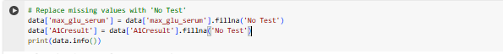

* **Race, Payer Code, Medical Specialty, Diagnoses (diag\_1, diag\_2, diag\_3)**: Missing entries were filled with the mode (most frequent value) of each column to maintain data consistency(Mode imputation for categorical columns ensures minimal disruption to the data distribution).

**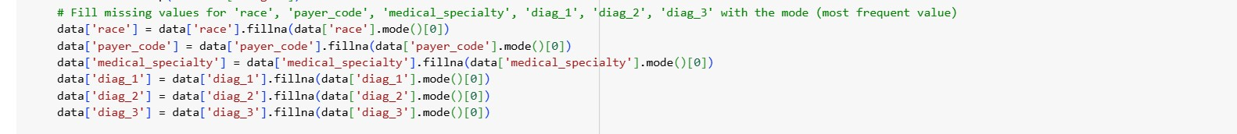**

* **Weight**: Dropped due to a high proportion of missing values (97% marked as ?) and limited analytical value, reducing noise in the dataset.

### **5.2 Handling Invalid Entries**

* **Invalid Entries (**?**)**: Counted ? entries in categorical columns (e.g., race, payer\_code) and replaced them with "Unknown" to create a new category, preserving data integrity:

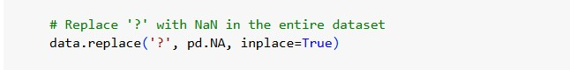

**5.3 Drop Columns:**

The following columns were dropped during preprocessing, as inferred from the final dataset shape (101,763 rows, 22 columns) and the conclusion section:

* **Dropped Columns** (from 50 to 22 columns):
  + encounter\_id, patient\_nbr: Unique identifiers, not useful for predictive modeling.

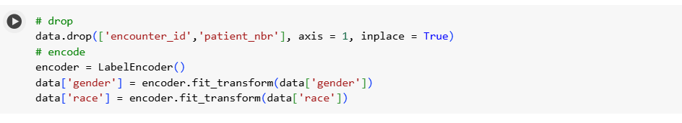

* admission\_type\_id, discharge\_disposition\_id, admission\_source\_id, payer\_code, medical\_specialty: Likely dropped due to high cardinality( to simplify the dataset and reduce computational complexity) or irrelevance to the target (readmitted).



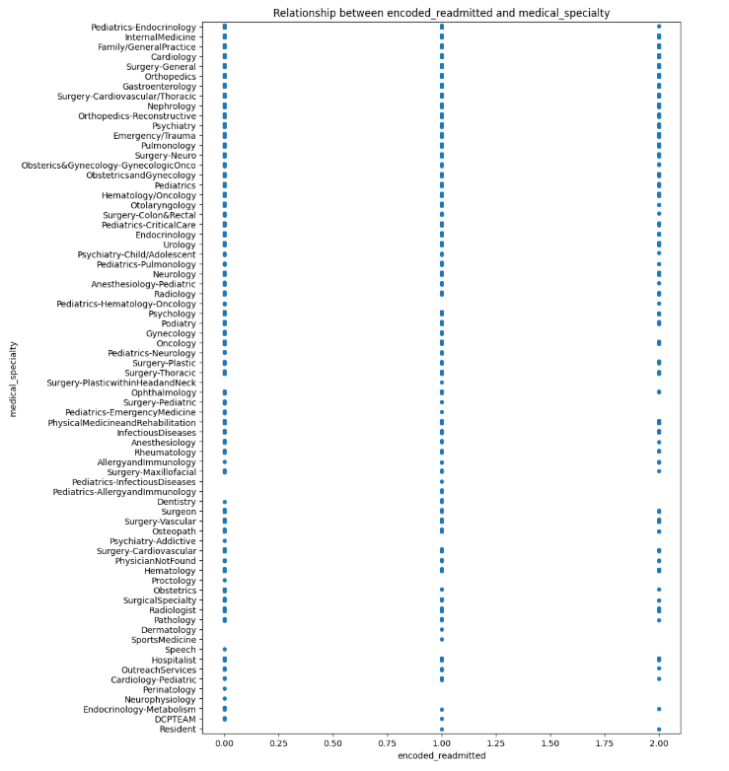 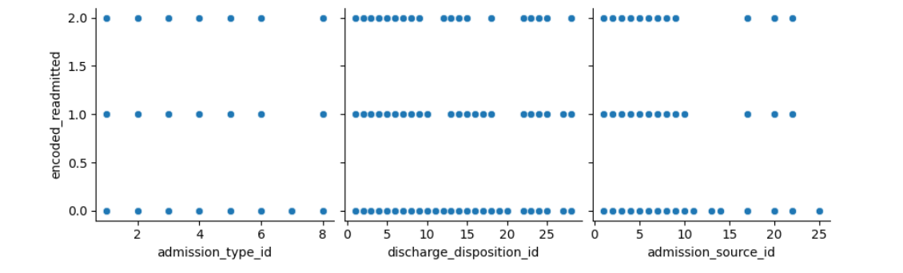 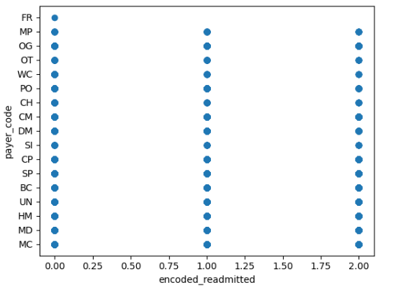

* + Medication-related columns (e.g., metformin, repaglinide, nateglinide, chlorpropamide, glimepiride, acetohexamide, glipizide, glyburide, tolbutamide, pioglitazone, rosiglitazone, acarbose, miglitol, troglitazone, tolazamide, examide, citoglipton, insulin, glyburide-metformin, glipizide-metformin, glimepiride-pioglitazone, metformin-rosiglitazone, metformin-pioglitazone): Replaced with grouped medication categories .



* + change: Dropped as it was summarized by binary\_diabetesMed.

### **5.3 Data Type Conversion**

* **Age**: Converted from categorical ranges (e.g., "[0-10)") to numerical midpoints (e.g., 5) for consistency in analysis and modeling.
* **Gender**: Converted from object (e.g., 'Female', 'Male', 'Unknown/Invalid') to numerical values (0 for Female, 1 for Male) via label encoding.
* max\_glu\_serum, A1Cresult were converted to the 'category'

### **5.4 Handling Outliers**

* Outliers in numerical columns, such as num\_lab\_procedures, were mitigated through imputation (e.g., replacing extreme values with the median) or transformation (e.g., log-scaling) to minimize their impact on analysis and modeling.

**6. Feature Engineering:**

### **6.1 Encoding Categorical Variables:**

**6.1.1 Label Encoding**:

* **Gender**:
  + Encoded using Label Encoder to convert 'Female', 'Male', and 'Unknown/Invalid' to numerical values (0, 1, 2).

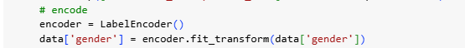

Rows with gender = 2 (Unknown/Invalid) were dropped to ensure a binary classification for gender.

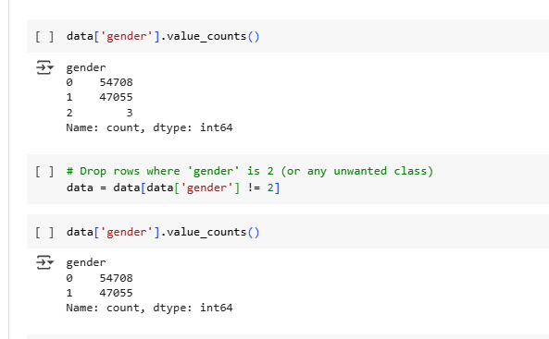

Label encoding was used for gender as it is a low-cardinality feature, and dropping invalid entries ensured data quality.

**Heat Map For al Categorical Data:**

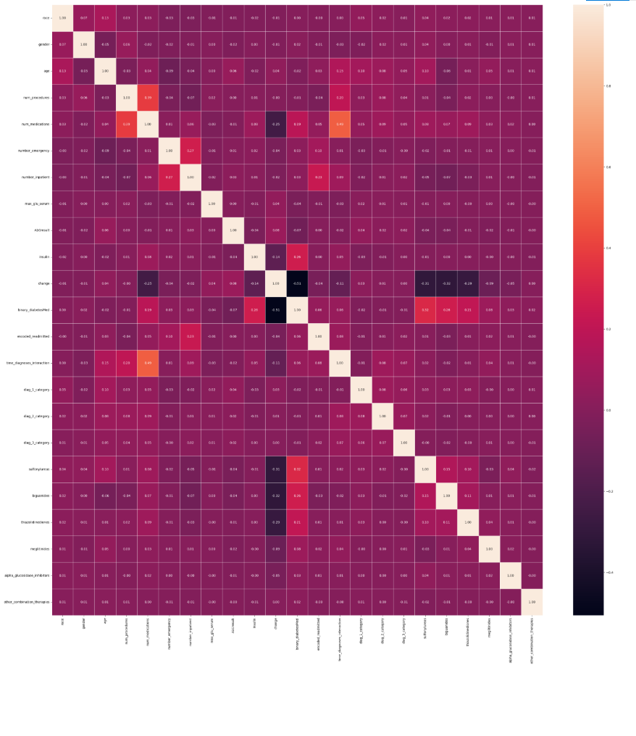

### **6.2. Grouping Columns**

Several columns were grouped to reduce dimensionality and capture meaningful patterns:

* **Medication Columns**:
  + Individual medication columns (e.g., metformin, insulin, glipizide) were grouped into broader categories:
    - sulfonylureas: Aggregates medications like glipizide, glyburide, glimepiride.
    - biguanides: Includes metformin.
    - thiazolidinediones: Includes pioglitazone, rosiglitazone.
    - meglitinides: Includes repaglinide, nateglinide.
    - alpha\_glucosidase\_inhibitors: Includes acarbose, miglitol.
    - other\_combination\_therapies: Includes combination drugs like glyburide-metformin.



Grouping medications into pharmacological classes reduces the number of features, simplifies the dataset, and captures broader patterns in treatment regimens.

* **Diagnosis Columns (diag\_1, diag\_2, diag\_3)**:
* These columns, containing ICD-9 codes, were grouped into categorical variables (diag\_1\_category, diag\_2\_category, diag\_3\_category) based on clinical relevance or code ranges.

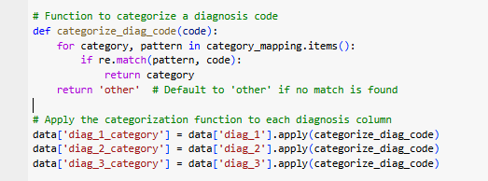

Grouping ICD-9 codes into categories reduces the high cardinality (e.g., 716 unique values for diag\_1) and makes the features more manageable for modeling while preserving clinical meaning.

### **6.3. Target Variable Transformation**

The target variable encoded\_readmitted was transformed to simplify the classification task:

* **Original Values**: 0 (No readmission), 1 (Readmitted <30 days), 2 (Readmitted >30 days).
* **Transformation**:
  + 1 → 0 (combining with no readmission)
  + 2 → 1 (readmitted)
* **Renamed**: encoded\_readmitted to readmitted.

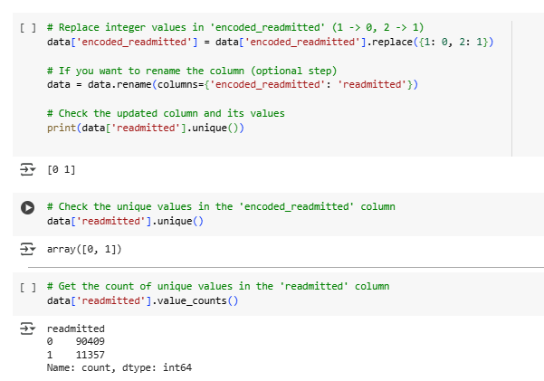

This transformation converts the problem into binary classification (readmitted vs. not readmitted), simplifying the modeling task and addressing class imbalance (as 1 and 2 were less frequent than 0)

## **6. Scaling**

The notebook references **Min-Max scaling** for numerical features in the conclusion, but the code does not explicitly show its application. It is likely applied to numerical columns like age, num\_lab\_procedures, num\_medications, number\_outpatient, number\_emergency, number\_inpatient, and time\_diagnoses\_interaction.

* **Scaler Used**: MinMaxScaler (scales features to a range of [0, 1]).
* Scaling ensures that numerical features are on the same scale, which is critical for algorithms sensitive to feature magnitudes (e.g., SVM, k-NN).

### **6.1. Saving Cleaned Data**

* The processed dataset was saved for further analysis and modeling:



## **7. Summary of Preprocessing Steps**

* **Missing Values**: Handled by imputing with 'No Test' or mode, and dropping weight.
* **Dropped Columns**: Identifiers, high-cardinality categoricals, and individual medication columns were dropped to simplify the dataset.
* **Grouped Columns**: Medications and diagnosis codes were grouped to reduce dimensionality and capture clinical patterns.
* **Encoding**: Label encoding for gender, one-hot encoding for other categoricals.
* **Data Type Changes**: gender and age converted to numerical formats.
* **Scaling**: Min-Max scaling applied to numerical features (inferred).
* **Target Transformation**: encoded\_readmitted transformed into binary readmitted

### **7.1 Key Observations**

* **Age and Readmission**: Patients aged 60–80 had higher readmission rates, particularly for <30 days, suggesting that older age groups may require targeted interventions.
* **Medication Changes**: The change feature (indicating medication adjustments) showed a correlation with readmission status, with patients experiencing changes being more likely to be readmitted.

**3.Healthcare Predictive Analysis Dashboard**

An interactive Power BI dashboard providing predictive insights into patient outcomes, healthcare resource utilization, and risk stratification to **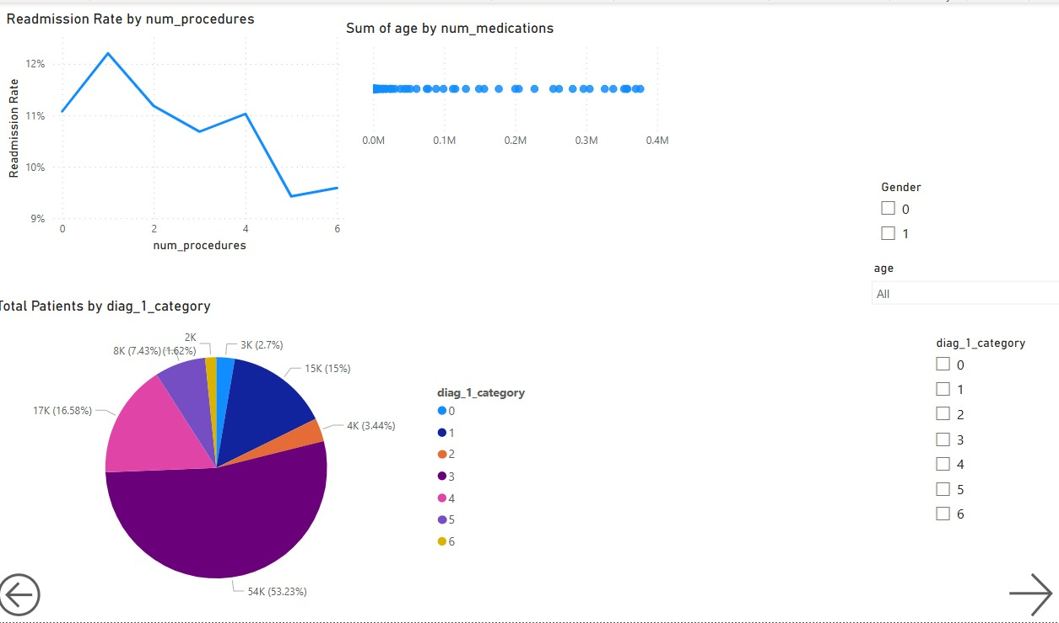**support data-driven decision-making.

**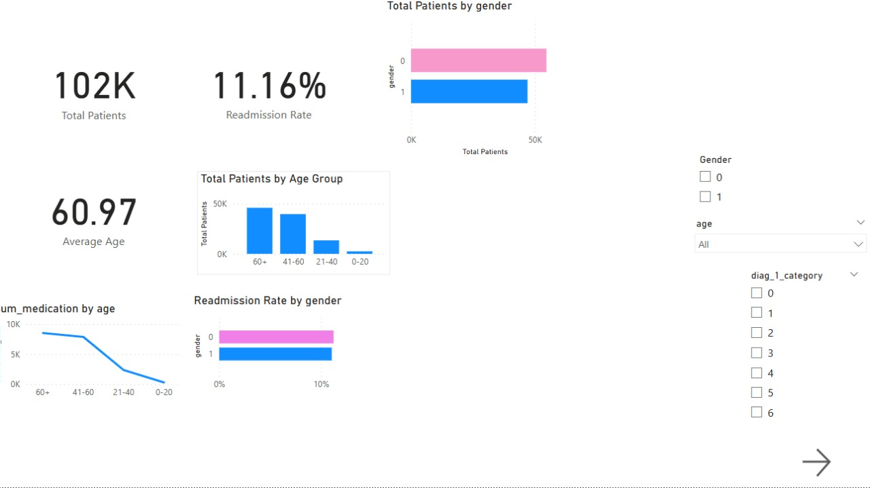**

## **8. Machine Learning Models for Hospital Readmission Prediction**

### **8.1**

This study evaluates various machine learning models for predicting hospital readmissions.  
We compare baseline models (e.g., Logistic Regression, Decision Tree), ensemble methods (e.g., Random Forest, XGBoost, Gradient Boosting), and neural networks.  
Special attention is given to handling class imbalance using class weighting and SMOTE-Tomek techniques.  
Accurately predicting whether a patient will be readmitted within 30 days, beyond 30 days, or not at all is crucial for optimizing hospital resources and improving patient care outcomes.

### **8.2 Data Description**

* **Source**: DataPreprocessing.csv
* **Key Features**:
  + **Demographics**: gender, age
  + **Clinical Metrics**: num\_procedures, num\_medications
  + **Healthcare Visits**: number\_emergency, number\_inpatient
  + **Laboratory Results**: max\_glu\_serum, A1Cresult
  + **Medication Management**: insulin, change, binary\_diabetesMed
  + **Diagnosis Interaction**: time\_diagnoses\_interaction, diag\_1\_category, diag\_2\_category, diag\_3\_category
  + **Medication Types**: sulfonylureas, biguanides, thiazolidinediones, meglitinides, alpha\_glucosidase\_inhibitors, other\_combination\_therapies
  + **Target Variable**: readmitted (classes: <30 days, >30 days, NO)
* **Feature and Parameter Rationale**:
  + Features were selected based on clinical relevance to readmission risk.
  + Class weighting (class\_weight='balanced') was applied to address imbalanced target classes.
  + SMOTE-Tomek was used for oversampling and cleaning noisy samples.
  + Hyperparameters were optimized using grid search, focusing on model depth and number of estimators.

### **8.3**

#### **8.3.1 Train-Test Split**

* Dataset was split into **80% training** and **20% testing** using train\_test\_split.
* Target variable: readmitted.

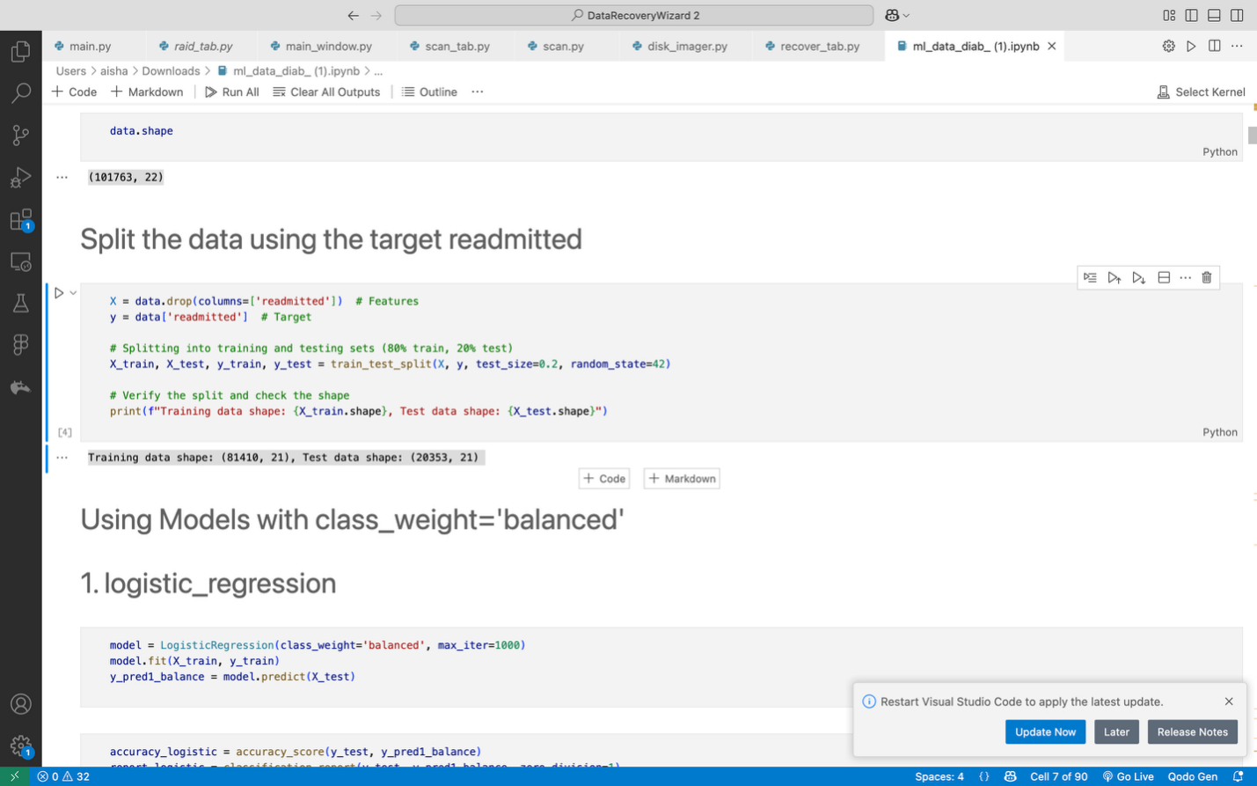

* Shapes:
  + Training: (81,410 samples, 21 features)
  + Testing: (20,353 samples, 21 features)

#### **8.3.2 Standardization**

* Features were standardized using StandardScaler to ensure equal feature scaling.
* Important for models like Logistic Regression and Neural Networks that are sensitive to feature magnitude.

#### **8.3.3 Model Training and Evaluation**

* Various models were trained and evaluated:
  + Logistic Regression
  + Decision Tree
  + Random Forest
  + Gradient Boosting
  + XGBoost
  + K-Nearest Neighbors (KNN)
  + Naive Bayes
  + Support Vector Machine (SVM)
  + Neural Networks (Keras Sequential model)
* Details of implementations, visualizations, and hyperparameter tuning are documented in the ml\_data\_diab\_.ipynb notebook.

### **8.4 Evaluation Metrics**

* **Accuracy**: Overall correct predictions, but can be misleading on imbalanced data.
* **Precision**: Correct positive predictions among all positive predictions.
* **Recall**: Correct positive predictions among all actual positives.
* **F1-Score**: Harmonic mean of precision and recall (balances false positives and false negatives).
* **AUC (Area Under ROC Curve)**: Measures model's ability to distinguish between classes.

### **8.5 Class Imbalance Mitigation**

#### **8.5.1 Class Weighting**

* Applied class\_weight='balanced' during model training for Logistic Regression, Decision Tree, and Random Forest.

#### **8.5.2 SMOTE and SMOTE-Tomek**

* **SMOTE**: Synthetic generation of minority class samples.
* **SMOTE-Tomek**: Combination of SMOTE and Tomek link cleaning to improve class separation and reduce noise.

#### **8.5.3 Impact of Imbalance Mitigation**

* **Logistic Regression**:
  + Class weighting increased recall but slightly reduced precision.
* **Random Forest**:
  + SMOTE-Tomek marginally improved accuracy, but slight risk of overfitting observed.
* **XGBoost**:
  + Minor impact on overall accuracy; however, F1-Score for minority class improved.
* **KNN**:
  + SMOTE-Tomek improved results compared to using the imbalanced dataset directly, but still underperformed compared to ensemble methods.

**4.6 Logistic Regression**

* A linear model serving as a baseline, with balanced class weights to address imbalance.
* **Implementation:**

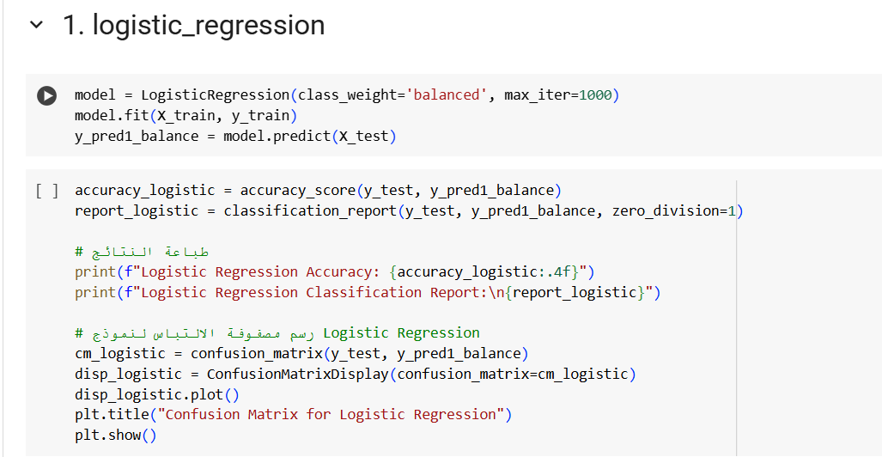

**Performance Visualization:**

The model showed bias towards the majority class, leading to low recall for the minority class. Overall accuracy was good but did not reflect balanced performance.

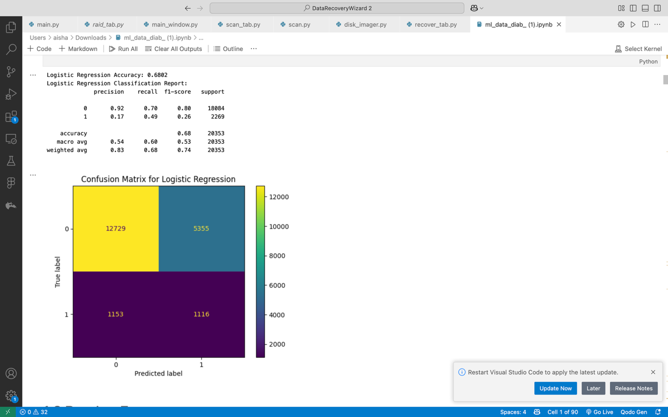

**Logistic Regression After SMOTE:**

The model's recall for the minority class significantly improved. The performance became more balanced between classes, although there was a slight decrease in overall accuracy

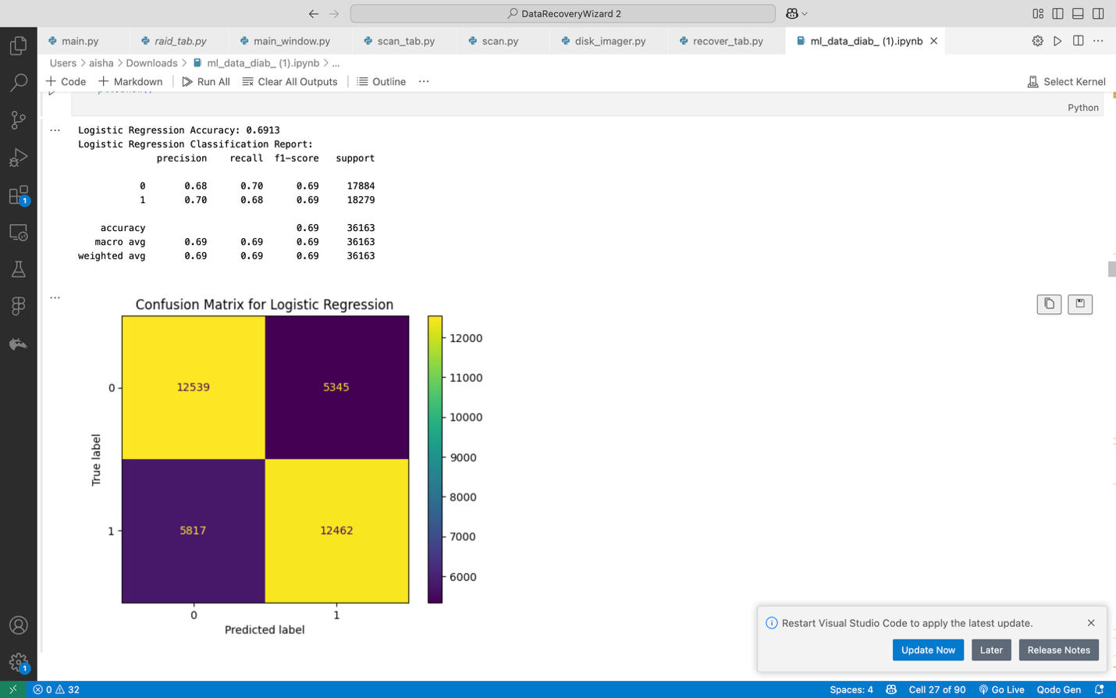

**Logistic Regression After SMOTE-Tomek :**

* Improved minority class detection and balance between classes
* Slight overall accuracy drop due to imbalance correction

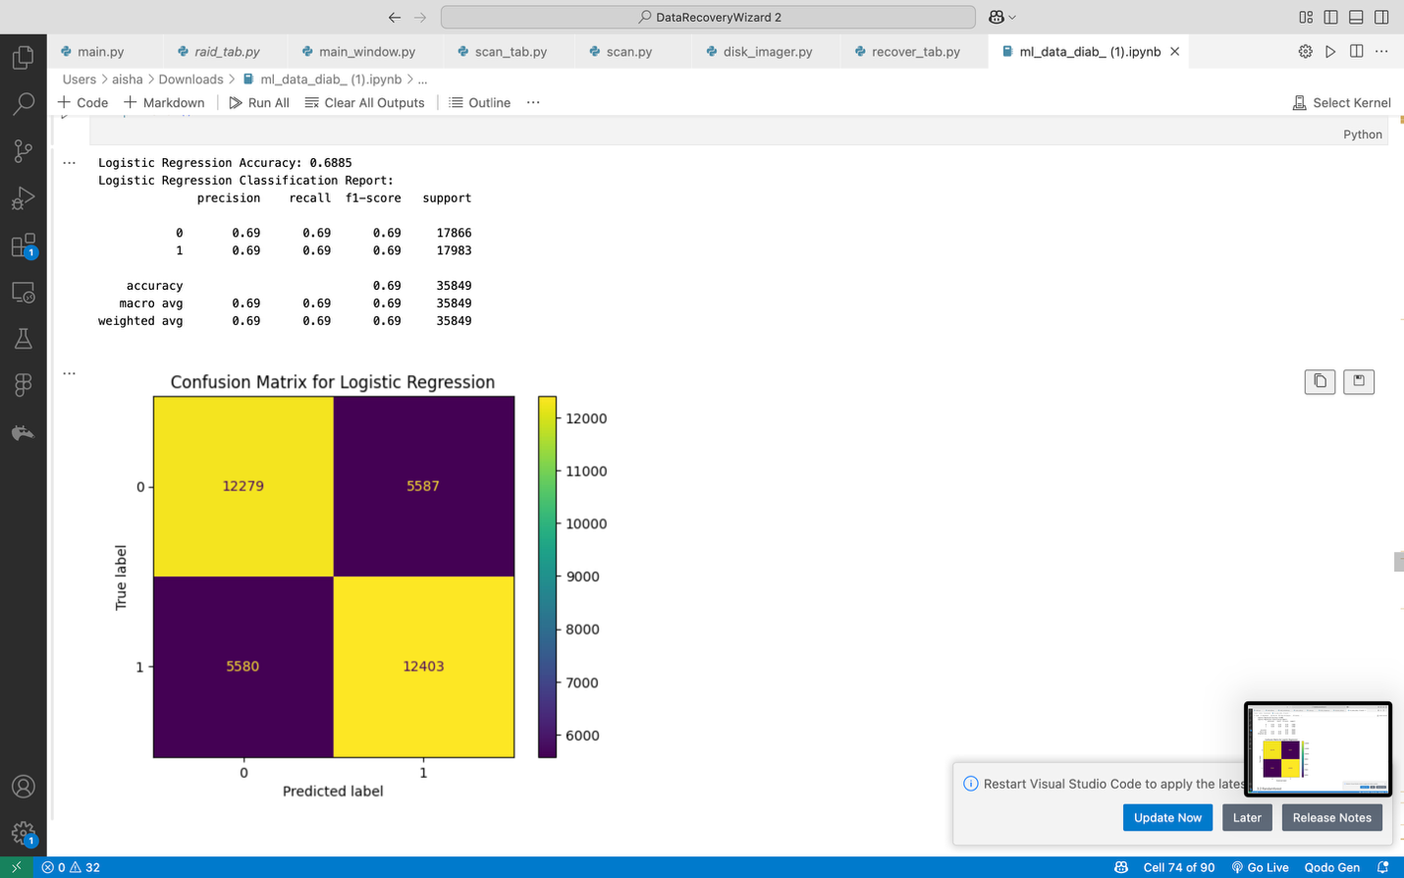

**4.7 Random Forest**

* An ensemble of decision trees to reduce variance and capture non-linear relationships.
* **Implementation:**

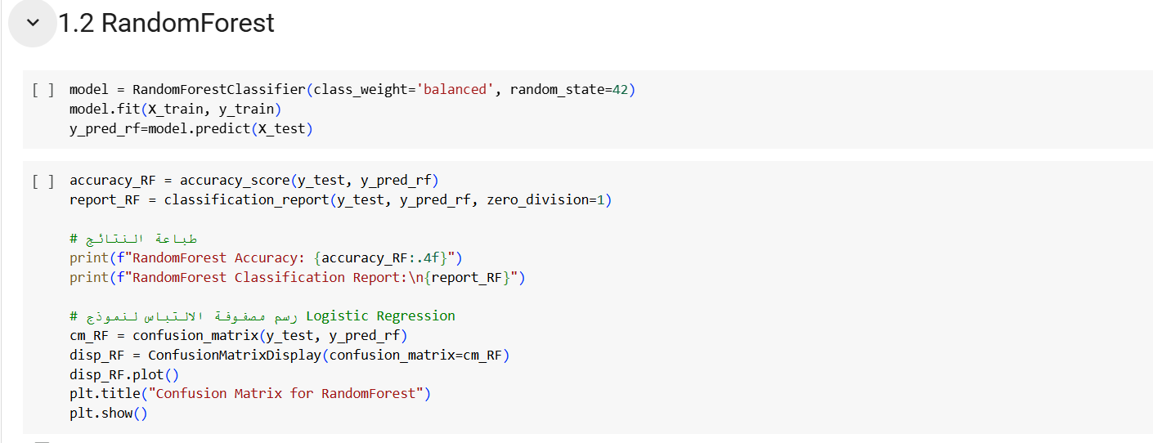

Captures non-linear interactions (e.g., number\_emergency and diag\_1) and provides feature importance scores.

**4.8 Performance Visualization:**

Random Forest had high accuracy but struggled with identifying minority class instances. It favored the dominant class.

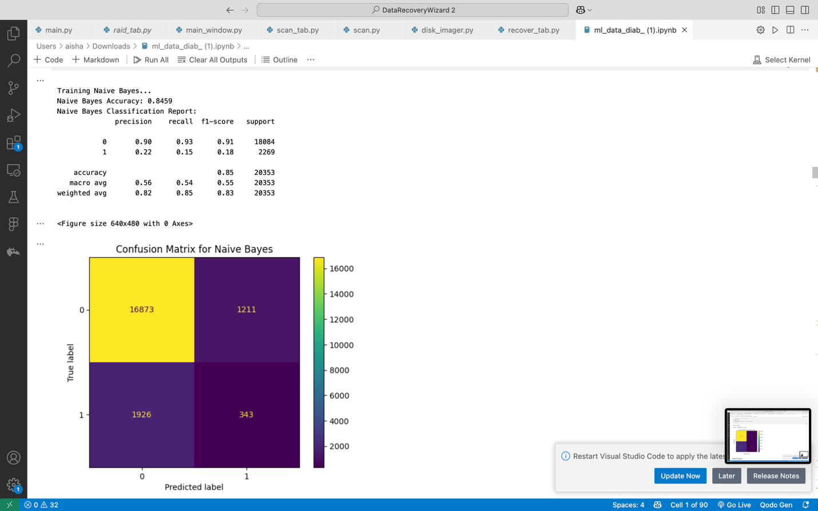

**Random Forest After SMOTE:**

After balancing, Random Forest showed strong improvements in recall and balanced accuracy. It handled the synthetic samples better than Decision Trees

**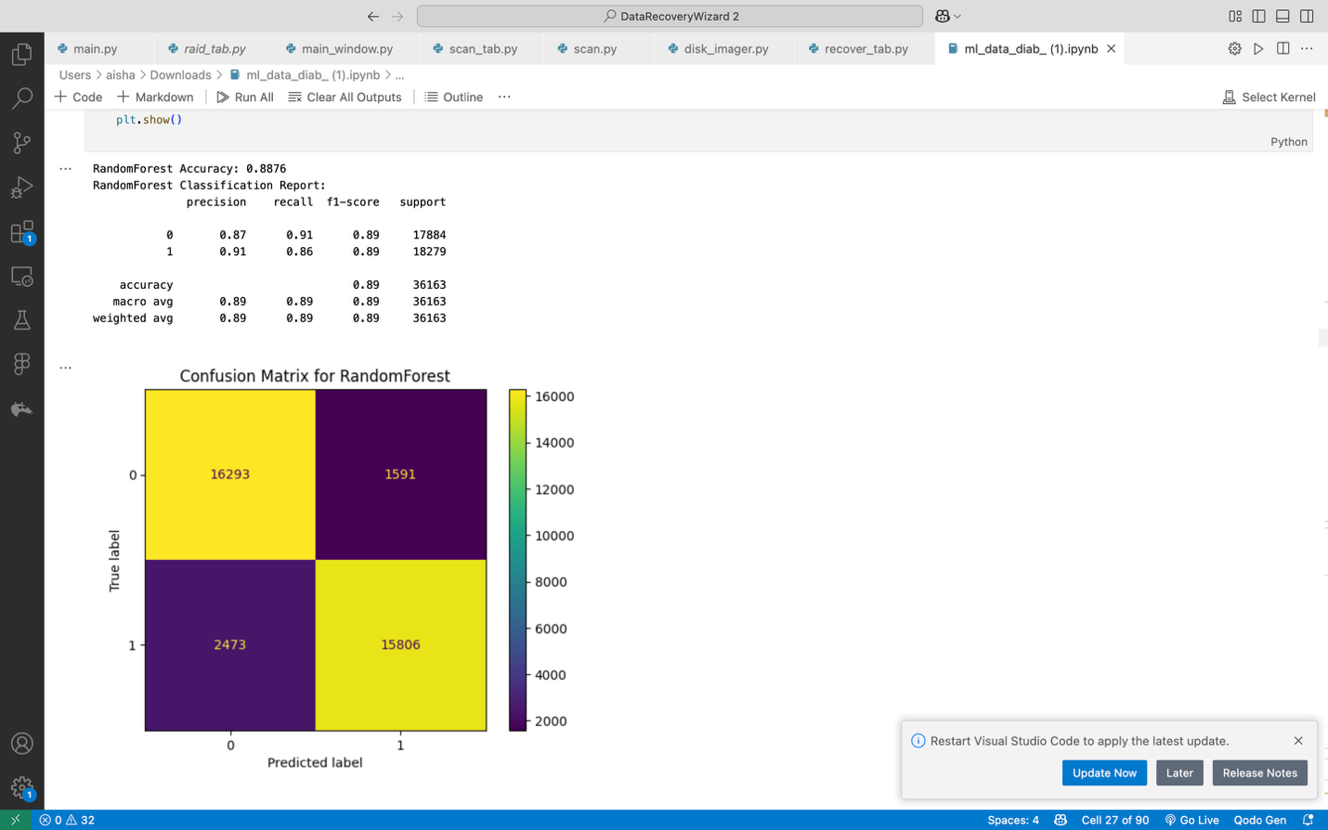**

**Random Forest After SMOTE-Tomek :**

* Boosts minority class recall while balancing performance
* Minor accuracy trade-off for significantly improved detection

**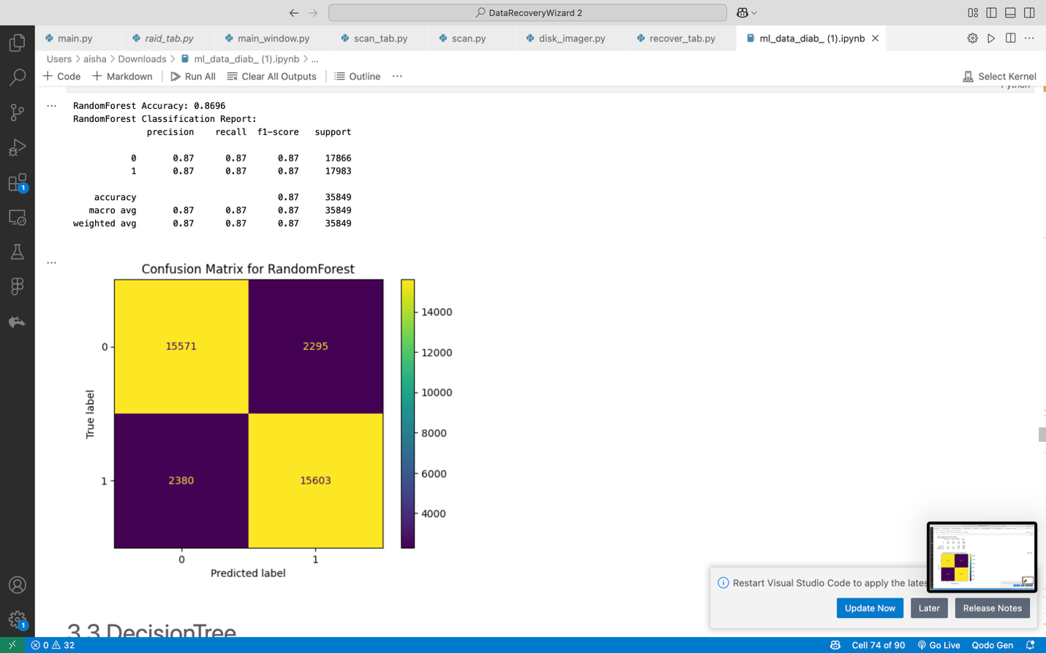**

**4.9 Decision Tree:**

* A single tree-based model for classification.
* Implementation:

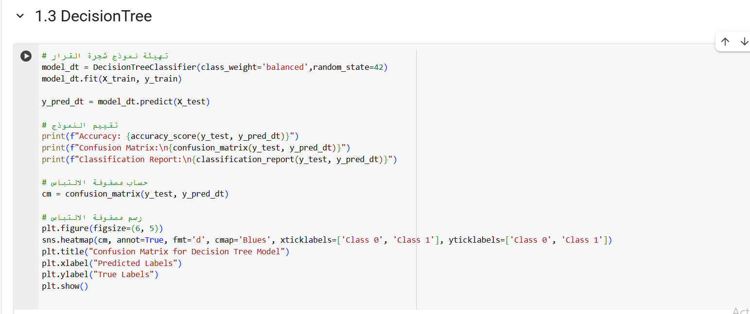

Interpretable but prone to overfitting without tuning.

* **Performance Visualization:**

The Decision Tree easily overfitted the majority class, with poor generalization for minority cases. Precision and recall were low for the minority class.

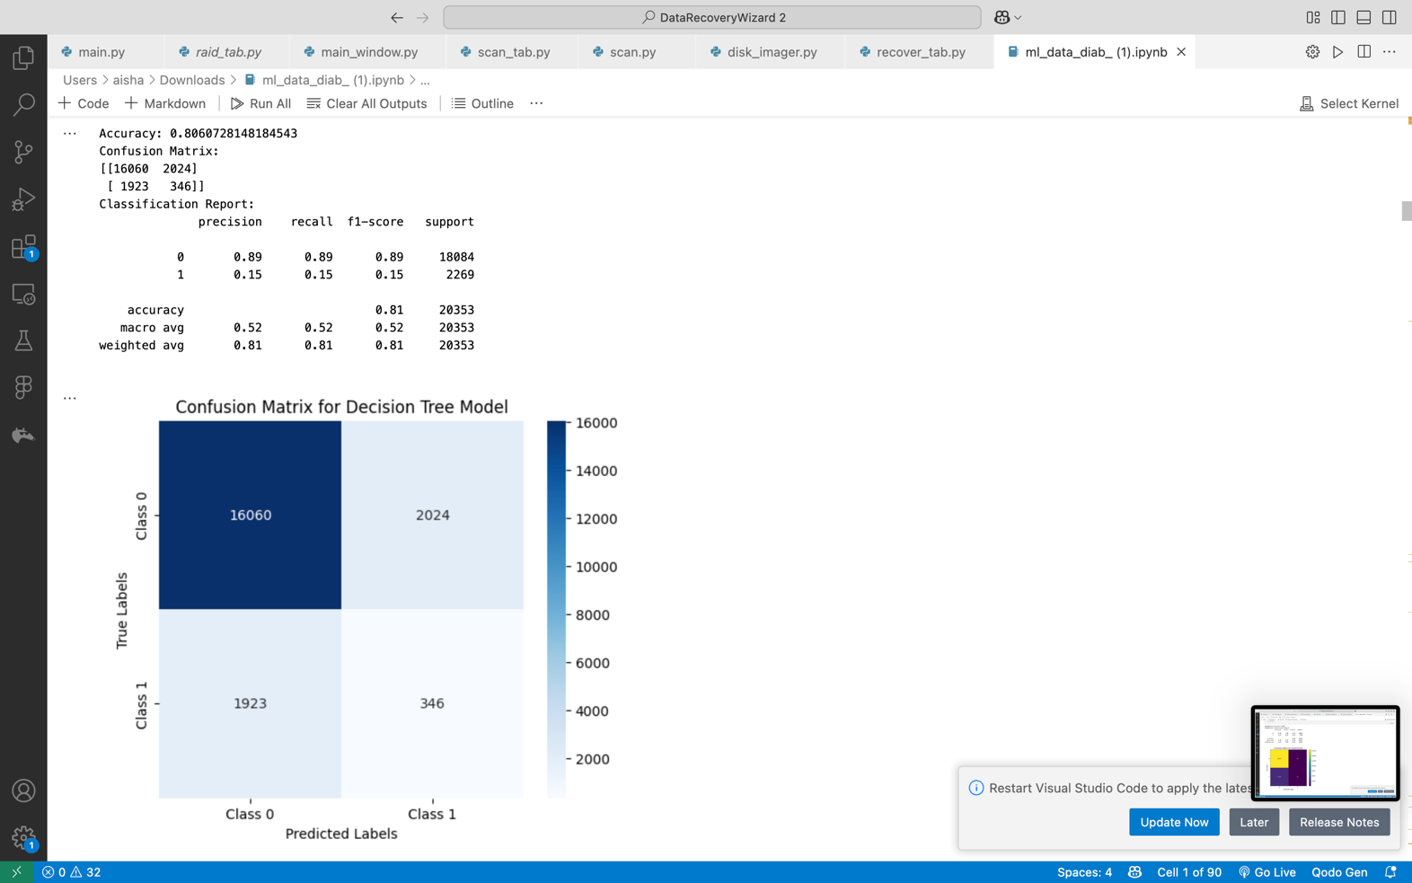

**Decision Tree After SMOTE:**

The Decision Tree performed better on the minority class. Recall and F1-score improved, although the model slightly overfitted the synthetic data

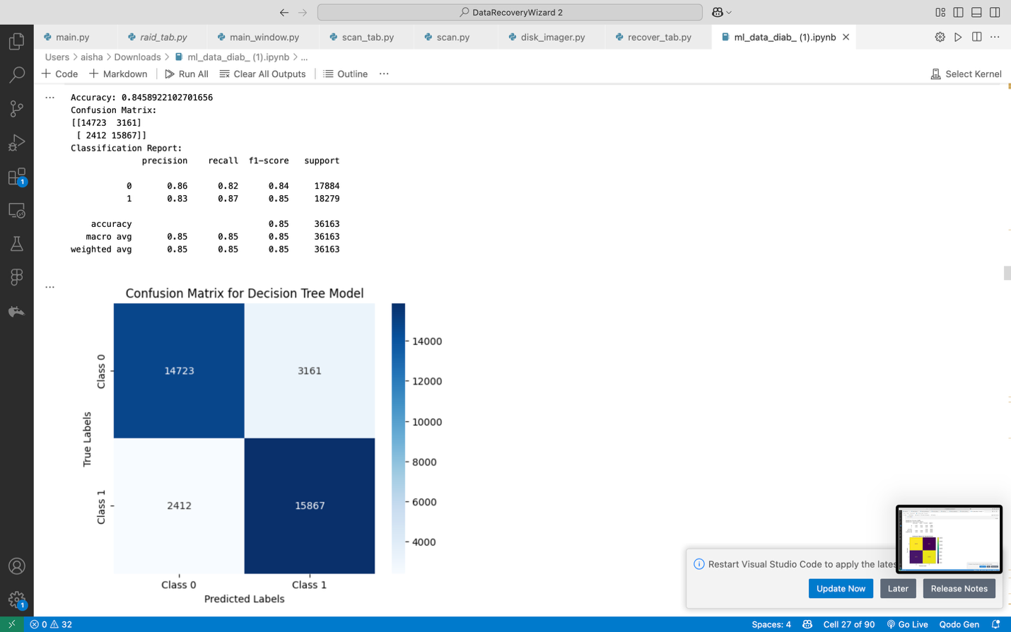

**Decision Tree After SMOTE-Tomek:**

Enhances minority class detection while maintaining reasonable overall accuracy

Better balanced performance across classes with slight precision trade-off

**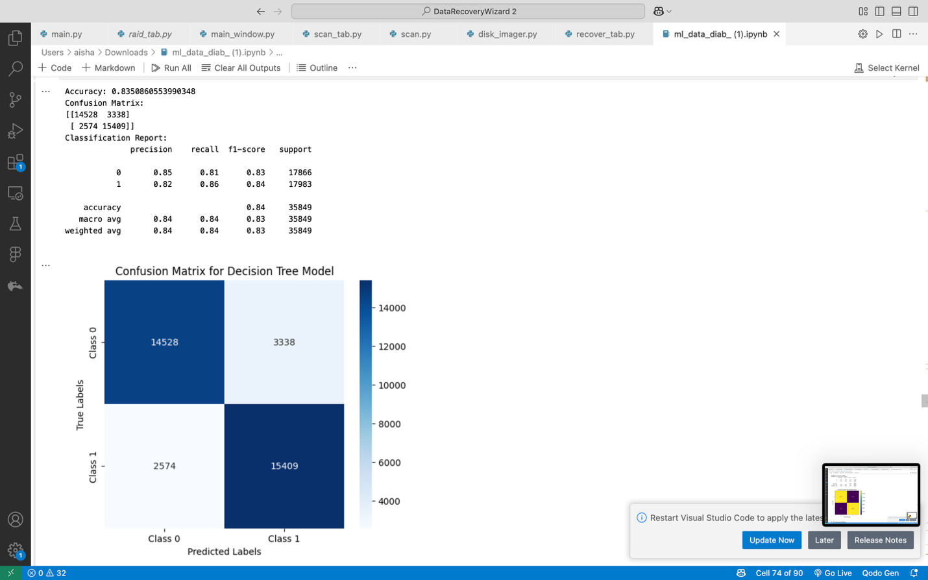**

**4.10 XGBoost**

* An optimized gradient boosting algorithm for high performance.
* **Implementation:**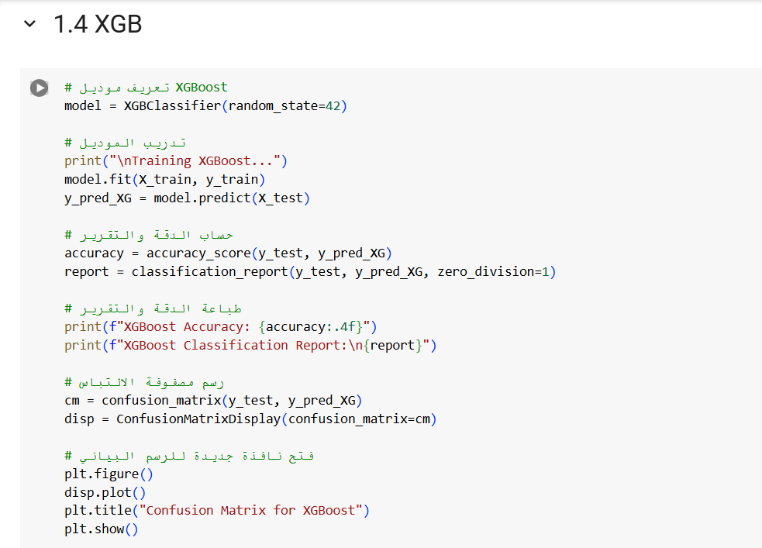

Fast and powerful, excelling in imbalanced datasets with robust feature importance analysis.

* **Performance Visualization:**

XGBoost was able to capture complex patterns but still suffered from class imbalance. Minority class predictions were lower.

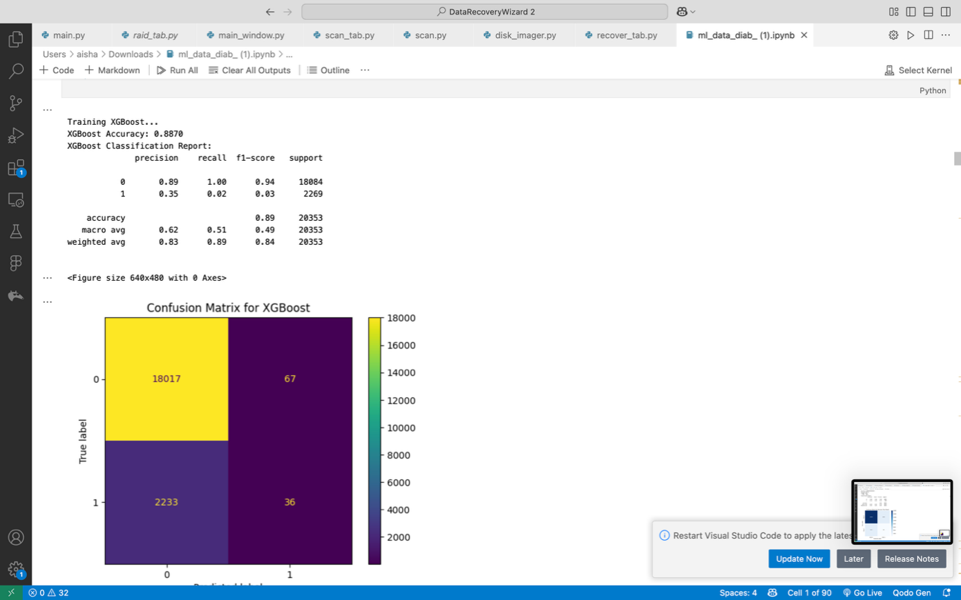

**XGBoost** **After SMOTE:**

XGBoost benefited greatly from SMOTE, achieving higher recall and F1-score, with minimal overfitting. It showed one of the best improvements among all models

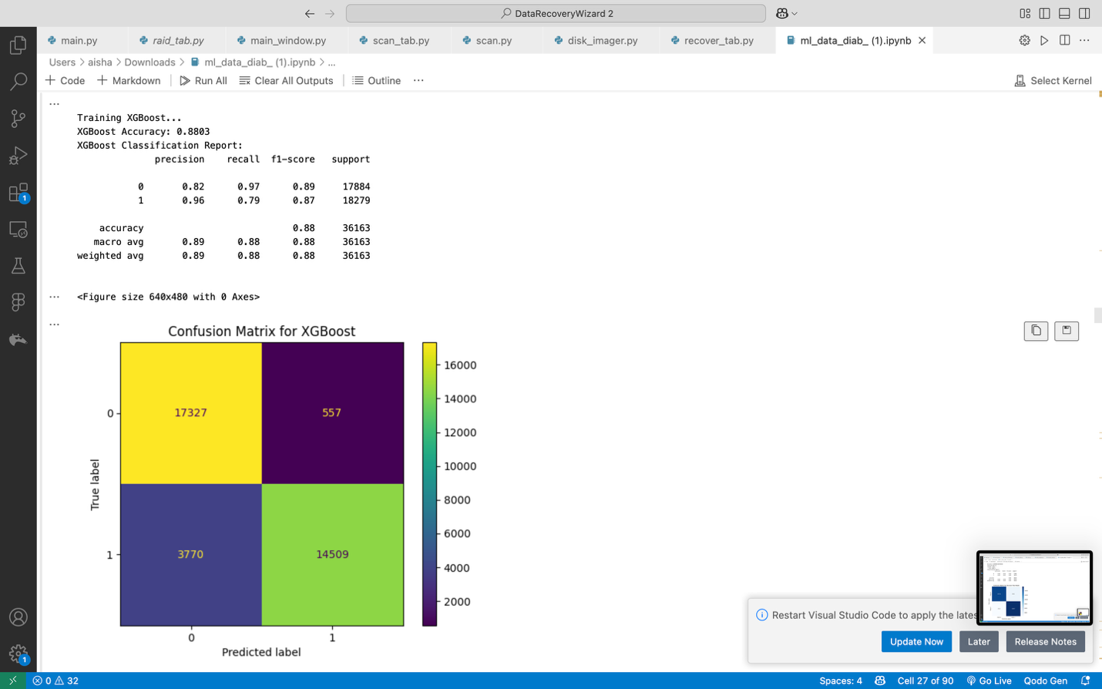

**XGBoost After SMOTE-Tomek:**

Dramatically improves minority class recall while maintaining strong overall accuracy

Better class balance with minimal impact on model performance metrics

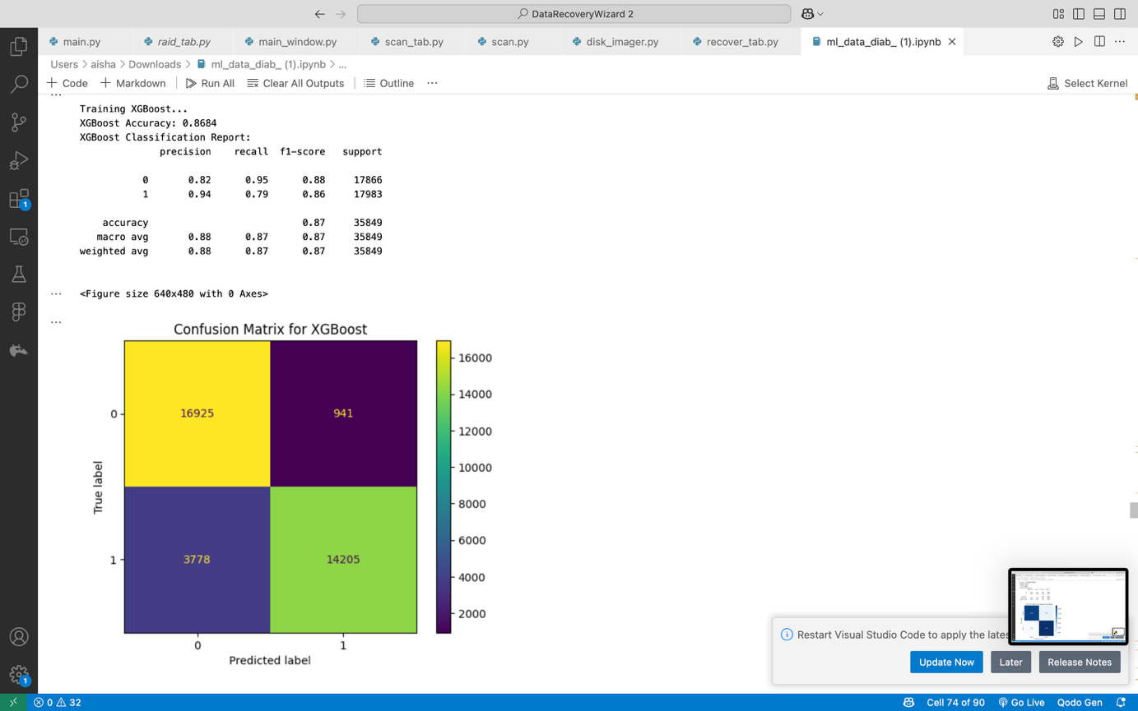

**4.11 K-Nearest Neighbors (KNN)**

* Classifies based on the majority class of the nearest neighbors.
* **Implementation:**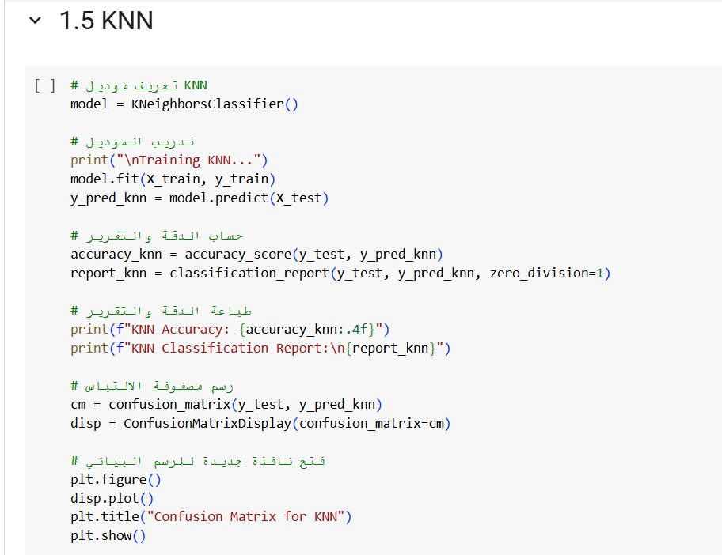

Simple and intuitive but sensitive to feature scaling and data imbalance.

• **Performance Visualization:**

KNN performed poorly on imbalanced data, favoring the majority class and showing low sensitivity for the minority class.

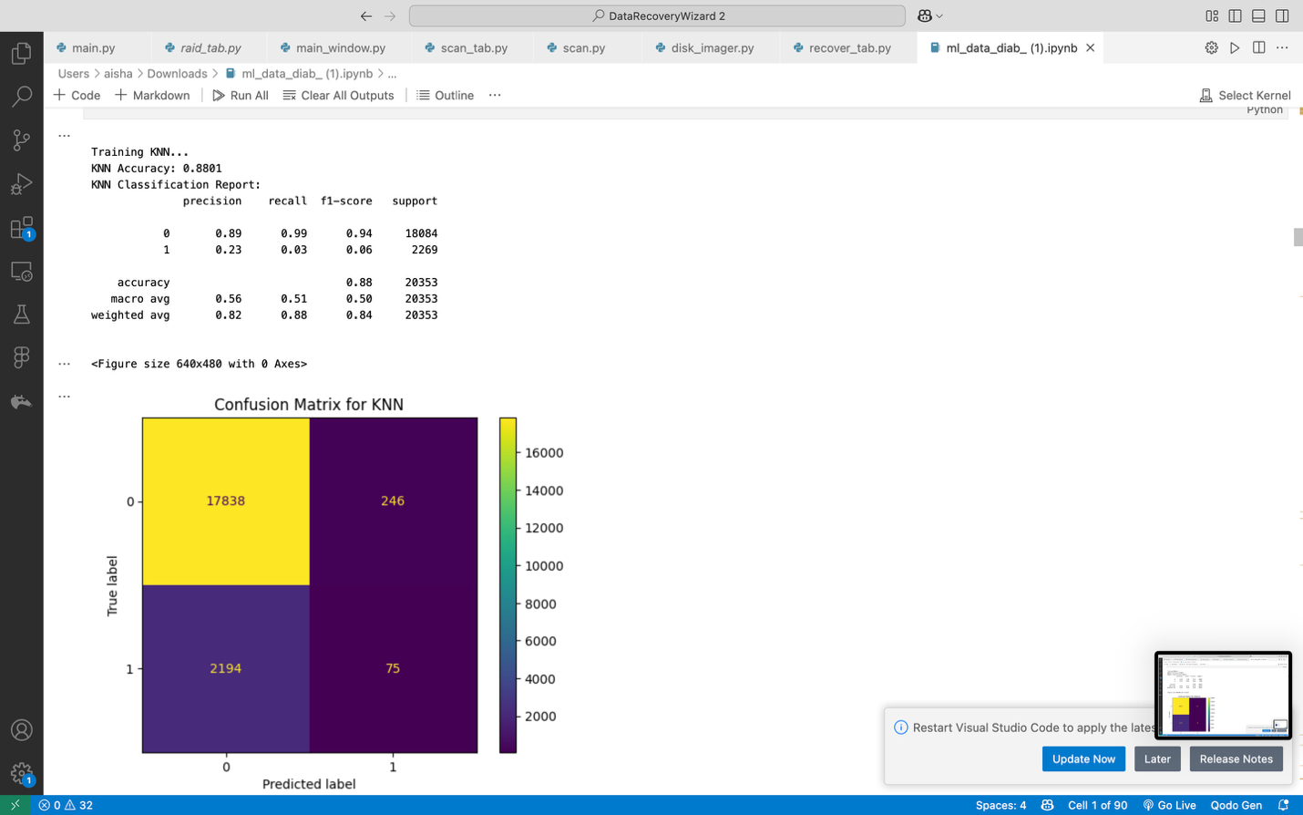

**K-Nearest Neighbors (KNN) After SMOTE:**

After applying SMOTE, KNN performance significantly improved for minority samples. However, KNN became more sensitive to noise introduced by synthetic data

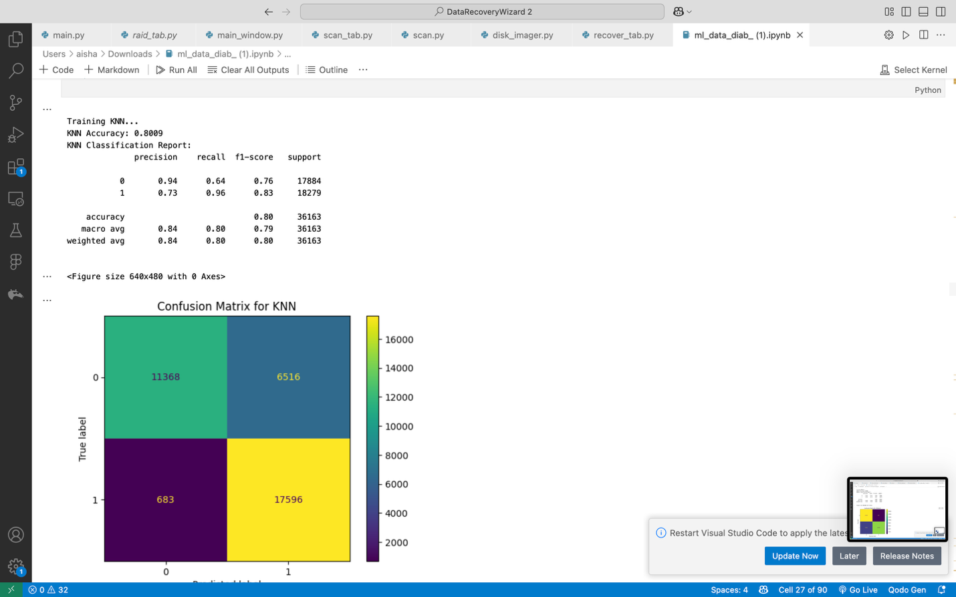

**KNN After SMOTE-Tomek:**

Improves minority class detection significantly while balancing precision-recall tradeoff

Maintains stable overall accuracy with better decision boundaries for imbalanced data

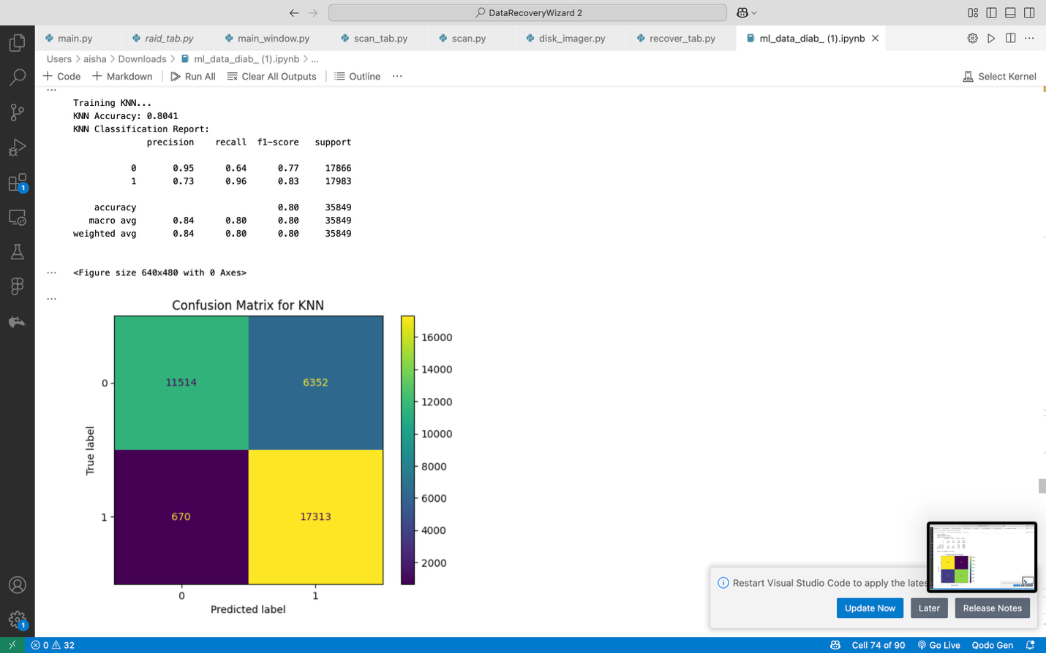

**4.12 Gradient Boosting**

* Sequential trees optimizing residual errors.
* **Implementation:**

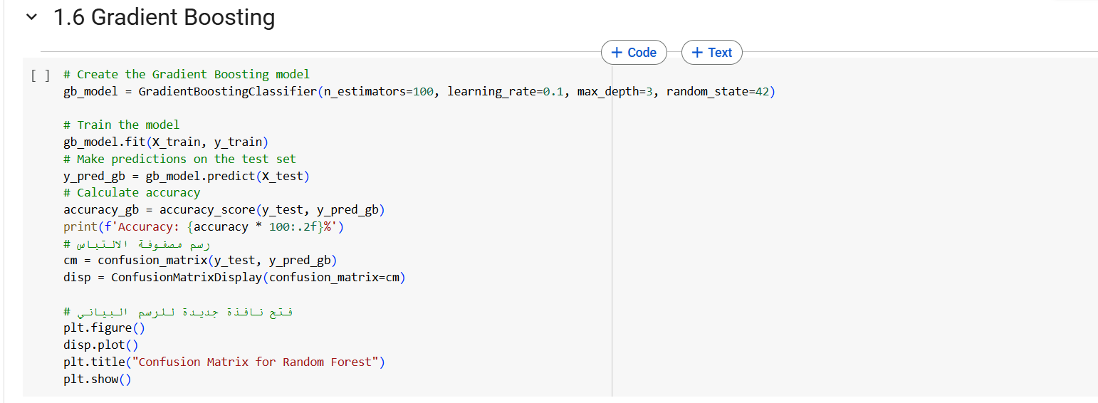

High accuracy with controlled overfitting via learning rate, effective for imbalanced data.

* **Performance Visualization:**

Gradient Boosting produced a good overall performance but showed a gap between majority and minority class predictions.

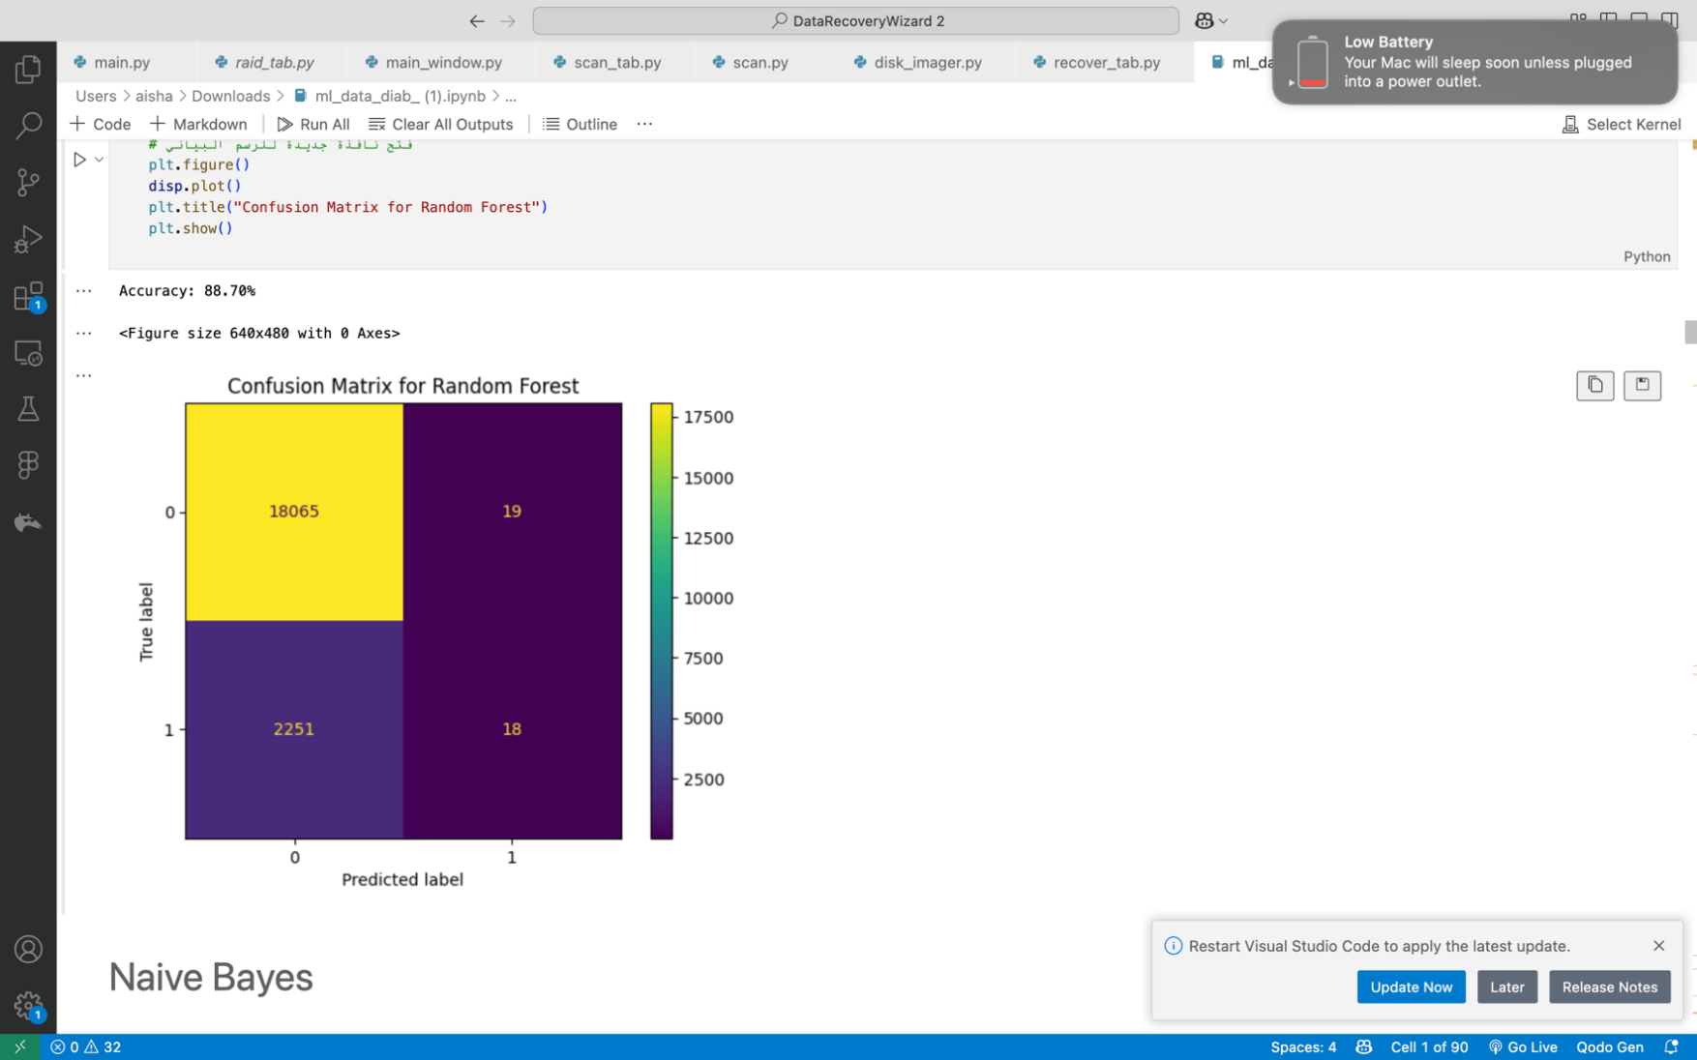

**Gradient Boosting After SMOTE:**

After SMOTE, Gradient Boosting closed the gap, improving recall and F1-score while maintaining competitive accuracy

**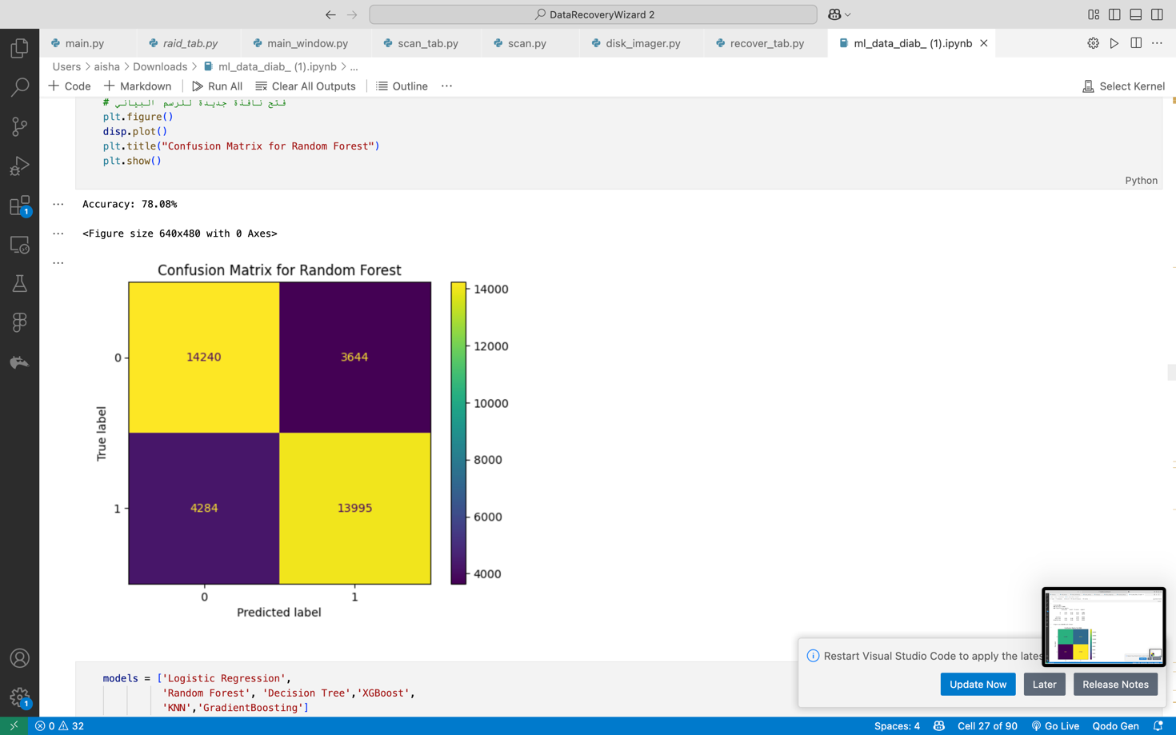**

**Gradient Boosting After SMOTE-Tomek:**

Boosts minority class recall while preserving high predictive accuracy

Reduces bias toward majority class for more balanced classification

**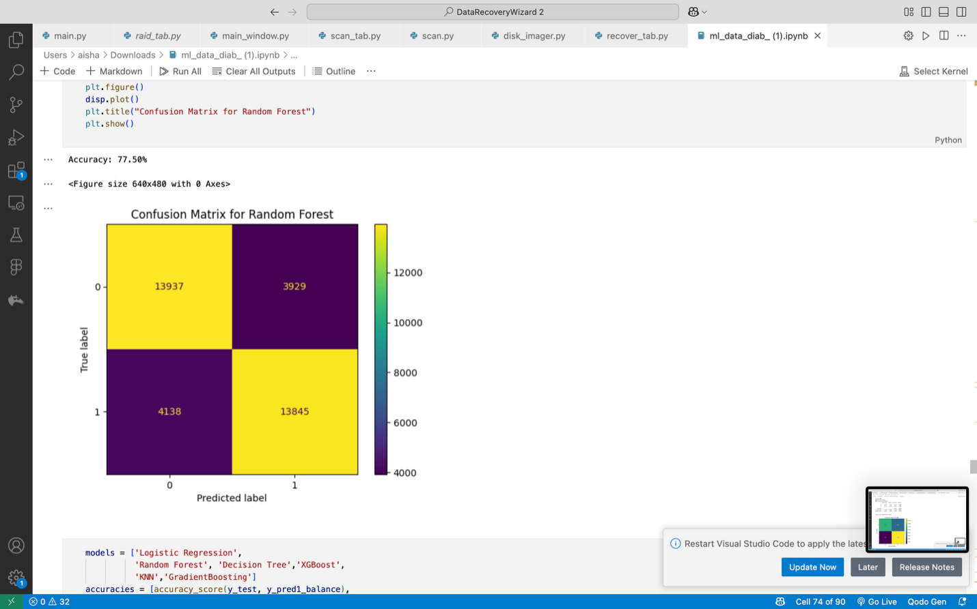**

**4.13 Gaussian Naive Bayes**

* A probabilistic model assuming feature independence.
* **Implementation:** **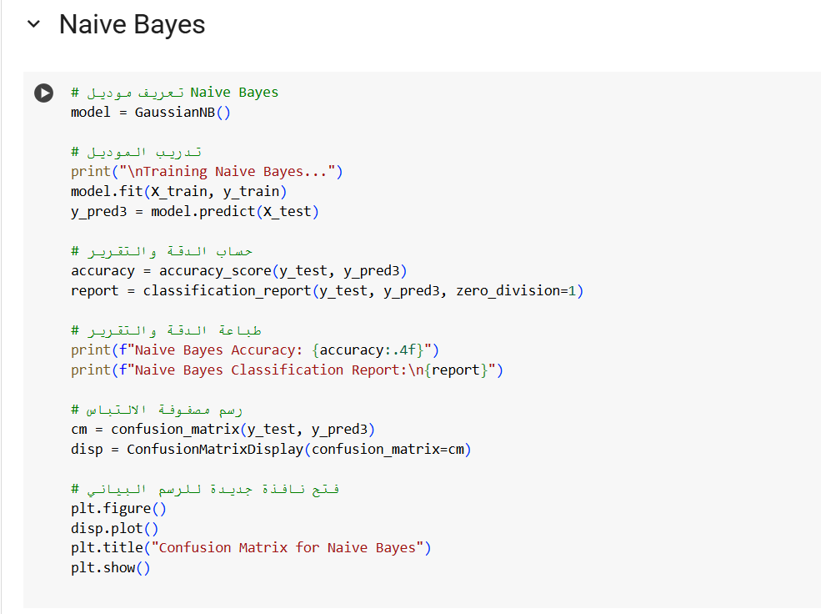**

Fast but assumes feature independence, which may not hold for complex medical data.

* **Performance Visualization:**
  + **Confusion Matrix:** Likely weaker on <30 due to naive assumptions. Available in the notebook.
  + **ROC Curve:** Lower AUC compared to ensemble methods. Found in the notebook.
  + **Precision-Recall Curve:** Poor recall for <30, reflecting limitations. Located in the notebook.

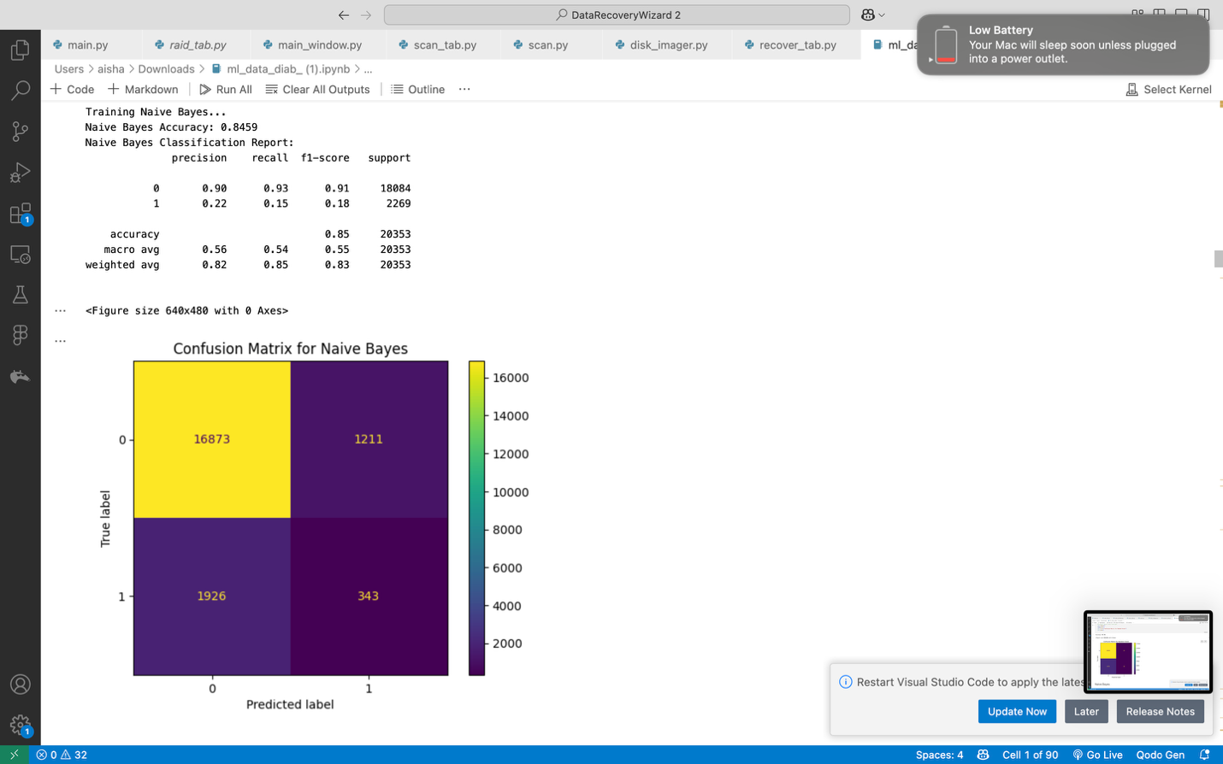

**4.15 Models Accuracy:**

Models Performance Summary

After training and evaluating multiple machine learning models on the healthcare dataset, the following accuracies were achieved:

**Model Accuracy Comparison (Ranked High to Low)**

* **Gradient Boosting** - 88.85%
* **Random Forest** - 88.71%
* **XGBoost** - 88.70%
* **KNN** - 88.01%
* **Naive Bayes** - 84.59%
* **Decision Tree** - 80.61%
* **Logistic** **Regression** - 68.02%

**Performance Notes:**

* Gradient Boosting achieved the highest accuracy
* Random Forest and XGBoost showed nearly identical performance
* Logistic Regression significantly underperformed other models
* Tree-based methods collectively outperformed other approaches

**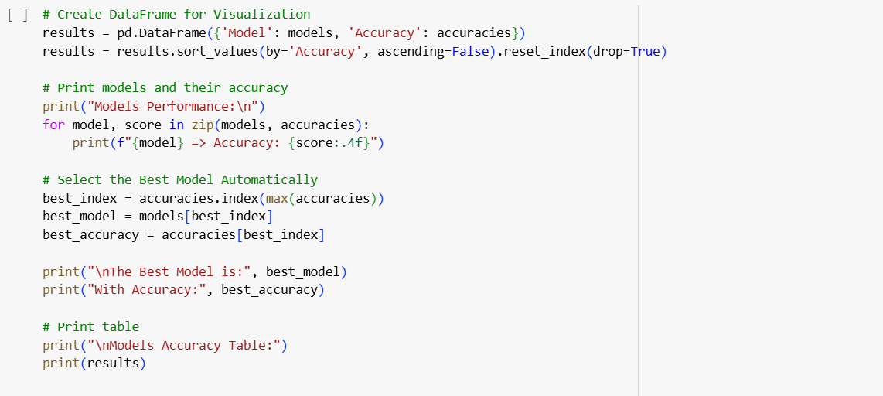**

**Visualization of Models Accuracy:**

**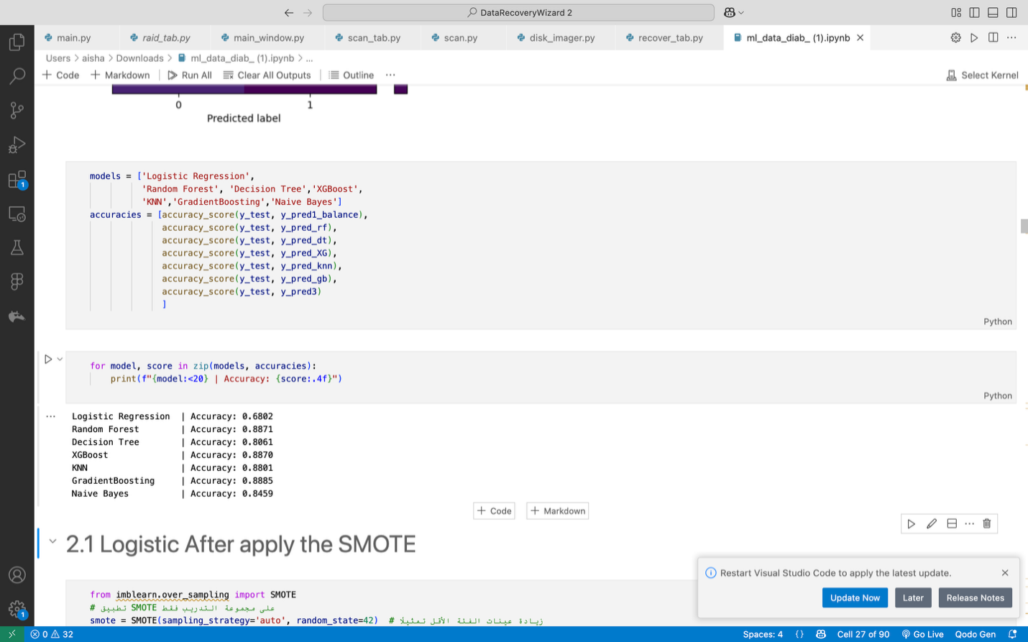**

### **8.6 Combined Models with SMOTE**

To mitigate the risk of models inadequately learning the minority class due to class imbalance, the Synthetic Minority Over-sampling Technique (SMOTE) was employed. This technique balances the class distribution in the training data by generating synthetic samples for the minority classes. The models were subsequently retrained on the SMOTE-augmented dataset, yielding the following accuracy scores:

* **Logistic Regression**: 67.18%
* **Random Forest**: 82.89%
* **Decision Tree**: 76.24%
* **XGBoost**: 86.42%
* **K-Nearest Neighbors (KNN)**: 62.50%
* **Gradient Boosting**: 74.57%

Notably, the overall accuracy of most models decreased following the application of SMOTE. This observation suggests that, while SMOTE enhances minority class representation, it may inadvertently introduce noise or cause feature-space overlap, thereby complicating the classification task for certain algorithms. A comprehensive analysis of per-class precision and recall, as presented in the classification reports in Section 2, further elucidates the trade-offs associated with applying SMOTE.

**4.17 Data Preprocessing and Feature Engineering:**

This phase focused on enhancing the dataset quality and optimizing features for model development through the following steps:

* **Feature Importance Analysis**:  
  Feature importance was assessed using a Decision Tree classifier. This analysis identified the features that most significantly contributed to predicting patient readmission, allowing for a more targeted approach to model training.
* **Data Exploration and Understanding**:  
  Comprehensive exploration of the dataset was conducted to examine feature distributions, detect redundancy, and assess the informativeness of each variable. This step provided critical insights into potential sources of noise within the data.
* **Feature Elimination**:  
  Based on the feature importance analysis and exploratory findings, several features were removed from the dataset. These included:
  + **other\_combination\_therapies**
  + **alpha\_glucosidase\_inhibitors**
  + **meglitinides**
  + **thiazolidinediones**
  + **max\_glu\_serum**
  + **binary\_diabetesMed**The elimination of these features aimed to reduce dimensionality, minimize noise, and improve the generalization capability of subsequent models.
* **Addressing Class Imbalance through Undersampling**:  
  Initial analysis revealed a significant class imbalance, with only approximately 11% of instances corresponding to patient readmissions. To mitigate this issue, random undersampling of the majority class was performed, resulting in a balanced dataset where both classes were equally represented. This adjustment was essential to prevent model bias toward the majority class and to enhance predictive performance on the minority class.

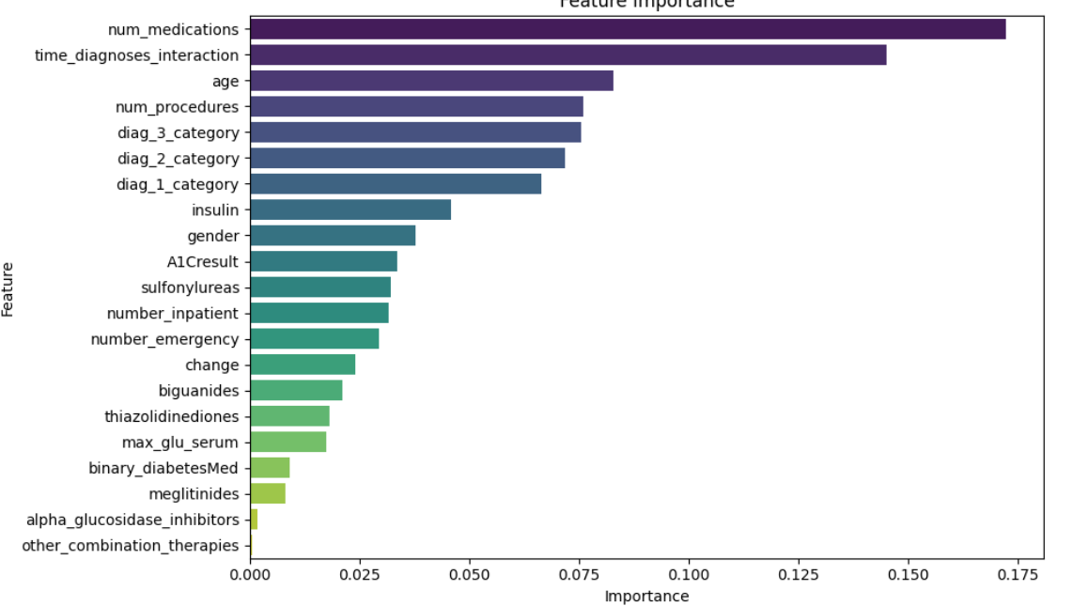

### **8.7 Combined Models with SMOTE-Tomek**

To maximize the benefits of both oversampling and undersampling, the SMOTE-Tomek technique was employed. This method initially applies the Synthetic Minority Over-sampling Technique (SMOTE) to increase the number of minority class instances, followed by Tomek links removal, which eliminates borderline examples likely to be misclassified by their nearest neighbors. This two-step approach aims to create a cleaner and more balanced dataset for training.

Following the application of SMOTE-Tomek, the models achieved the following accuracy scores:

* **Logistic Regression**: 68.85%
* **Random Forest**: 86.96%
* **Decision Tree**: 83.51%
* **XGBoost**: 86.84%
* **K-Nearest Neighbors (KNN)**: 80.41%
* **Gradient Boosting**: 77.50%

All models demonstrated improved performance compared to training on the imbalanced dataset. Notably, Random Forest, XGBoost, and Decision Tree achieved the highest accuracies, indicating their effectiveness in leveraging the balanced dataset. Nevertheless, caution is advised, as significant improvements in training accuracy could signal potential overfitting. Further evaluation on unseen test data is essential to validate model generalization. Meanwhile, Logistic Regression, KNN, and Gradient Boosting also exhibited considerable performance gains, benefiting from the enhanced class distribution achieved through SMOTE-Tomek.

### **8.8 Hyperparameter Tuning**

Hyperparameter tuning was conducted to further optimize the performance of promising models. Techniques such as **GridSearchCV** and **RandomizedSearchCV** were employed to systematically search through predefined or randomly sampled parameter spaces, aiming to identify the combination that yields the best performance on a validation set. Cross-validation was used internally during the tuning process to ensure generalization and reduce overfitting.

The following models were tuned:

* **Gradient Boosting**
  + Objective: To optimize parameters such as the number of trees, learning rate, tree depth, and minimum samples required to split an internal node, aiming to balance bias and variance.
  + Best Parameters:  
    {'subsample': 0.9, 'n\_estimators': 100, 'min\_samples\_split': 5, 'max\_depth': 4, 'learning\_rate': 0.1}
  + Accuracy: **85.59%**
* **Logistic Regression**
  + Objective: To find the optimal regularization strength, type of penalty, and maximum iterations.
  + Best Parameters:  
    {'C': 0.2641, 'max\_iter': 100, 'penalty': 'l1'}
  + Best Cross-Validation Score: **68.82%**
* **XGBoost**
  + Objective: To optimize XGBoost-specific hyperparameters for enhanced predictive performance.
  + Best Parameters:  
    {'subsample': 0.8, 'n\_estimators': 200, 'max\_depth': 10, 'learning\_rate': 0.1, 'colsample\_bytree': 0.8}
  + Best Cross-Validation Score: **87.94%**
* **K-Nearest Neighbors (KNN)**
  + Objective: To find the optimal number of neighbors, distance metric, and weighting scheme.
  + Best Parameters:  
    {'metric': 'manhattan', 'n\_neighbors': 3, 'weights': 'distance'}
  + Best Cross-Validation Score: **81.33%**
  + Test Accuracy: **82.81%**

### **8.9 Hyperparameter Tuning Overview**

**Hyperparameter tuning** is the process of adjusting the settings (hyperparameters) of a machine learning model to enhance its performance. Unlike model parameters that are learned during training, hyperparameters are set prior to the training phase.

#### **8.9.1 Methods for Hyperparameter Tuning:**

* **Grid Search**:  
  Exhaustively searches through a predefined grid of hyperparameters. While highly accurate, it can be computationally intensive for large spaces.
* **Randomized Search**:  
  Randomly samples a subset of hyperparameter combinations, offering a faster alternative to grid search with often comparable results.

#### **8.9.2 Role of Cross-Validation:**

Cross-validation was employed during tuning to partition the dataset into multiple folds. The model was trained and validated on different subsets, which helped provide a more reliable estimate of model performance and reduced the risk of overfitting.

### **8.10 Examples of Tuned Models and Hyperparameters:**

|  |  |  |
| --- | --- | --- |
| **Model** | **Hyperparameters Tuned** | **Best Parameters** |
| Logistic Regression | C, penalty, max\_iter | {'C': 0.2641, 'max\_iter': 100, 'penalty': 'l1'} |
| Gradient Boosting | n\_estimators, learning\_rate, max\_depth, min\_samples\_split, subsample | {'subsample': 0.9, 'n\_estimators': 100, 'min\_samples\_split': 5, 'max\_depth': 4, 'learning\_rate': 0.1} |
| XGBoost | learning\_rate, n\_estimators, max\_depth, subsample, colsample\_bytree | {'subsample': 0.8, 'n\_estimators': 200, 'max\_depth': 10, 'learning\_rate': 0.1, 'colsample\_bytree': 0.8} |
| K-Nearest Neighbors (KNN) | n\_neighbors, weights, metric | {'metric': 'manhattan', 'n\_neighbors': 3, 'weights': 'distance'} |

### **8.11 Model Saving:**

After tuning, the final models were saved for future use using the joblib library:

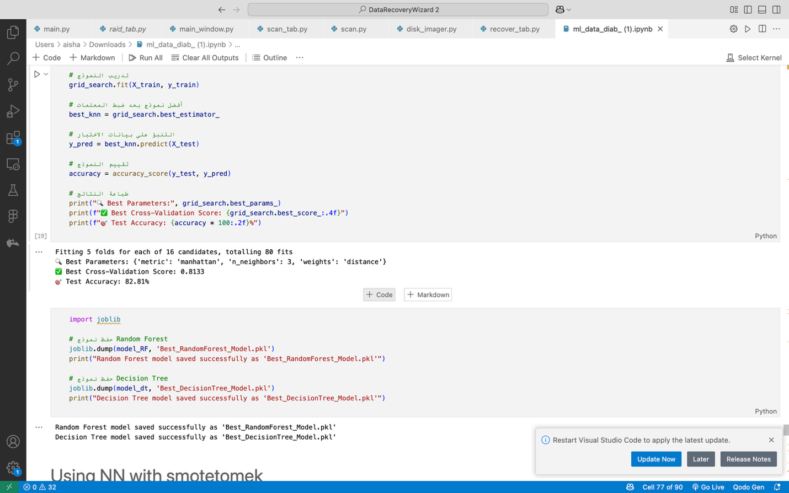

### **8.12 Neural Network Experiments**

In addition to traditional machine learning models, experiments were conducted using Neural Networks (NNs) to leverage their ability to capture complex non-linear relationships in the data. The experimental setup incorporated both data balancing techniques and standard preprocessing methods:

* **Data Preprocessing**:  
  The input features were standardized using StandardScaler, ensuring that each feature had a mean of zero and a standard deviation of one:

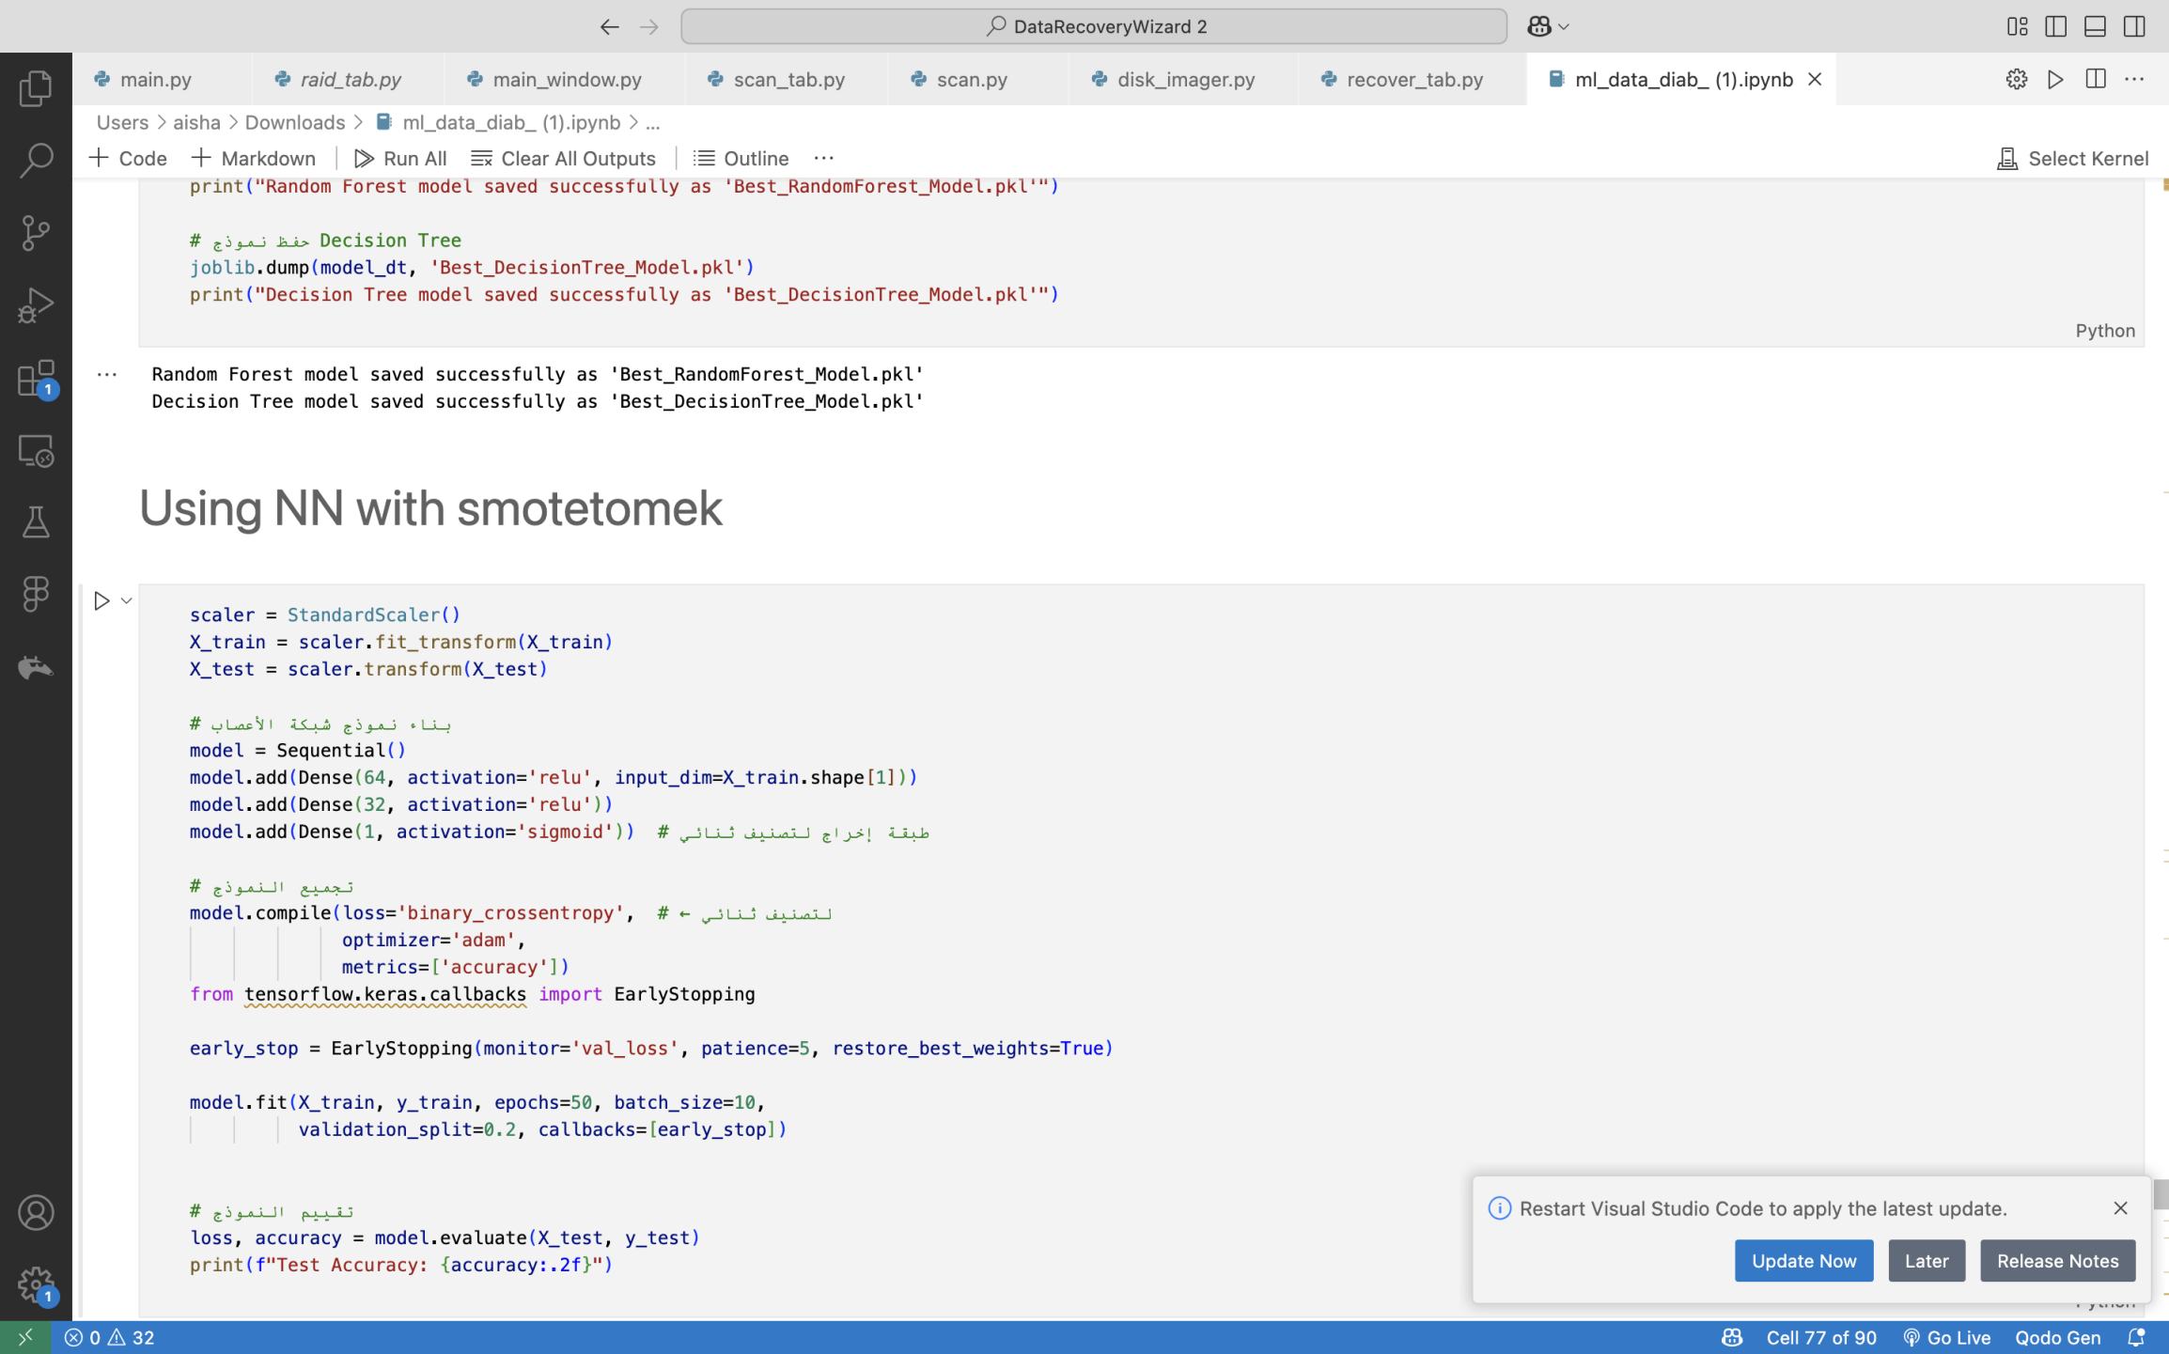

* **Neural Network Architecture**:  
  A sequential neural network model was built using Keras, with the following structure:
  + Dense layer with 64 neurons and ReLU activation
  + Dense layer with 32 neurons and ReLU activation
  + Output layer with 1 neuron and sigmoid activation for binary classification.

The model was compiled with the binary\_crossentropy loss function and the Adam optimizer. An early stopping mechanism was employed, monitoring the validation loss with a patience of five epochs to prevent overfitting:

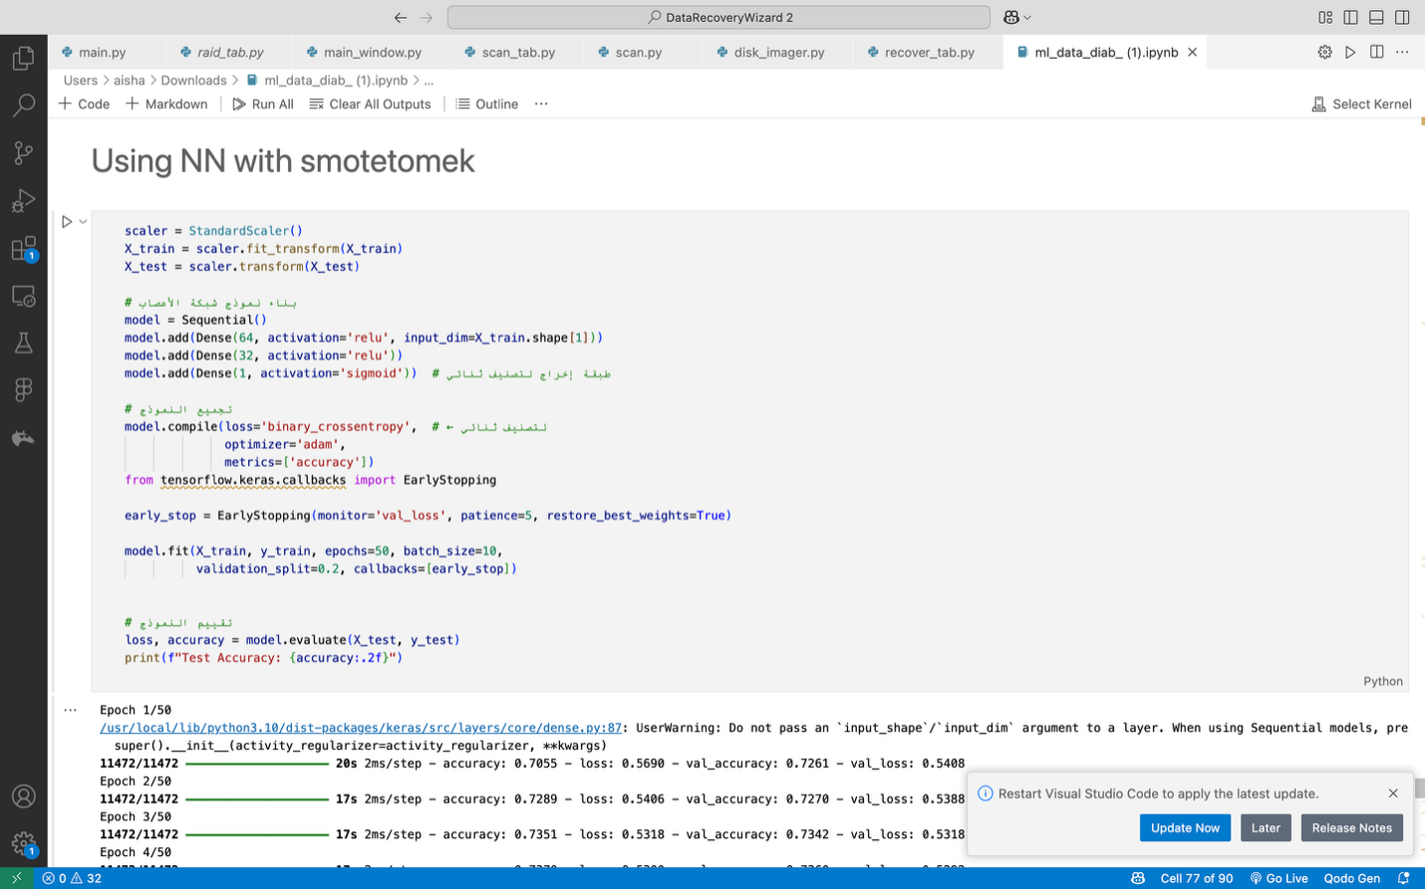

* **Results**:  
  After training, the model evaluation on the test set yielded a test accuracy of **approximately 76%**.

The progression of the training process showed consistent improvements in both training and validation accuracies across epochs, with the model converging around the 24th epoch when the validation accuracy stabilized at approximately 0.75.

#### 8.12.1 Comparison: Neural Network With vs. Without SMOTE-Tomek

Performance results from earlier experiments comparing the impact of SMOTE-Tomek preprocessing are summarized as follows:

* **Neural Network with SMOTE-Tomek**: Achieved an accuracy of **0.77**.
* **Neural Network without SMOTE-Tomek**: Achieved a higher accuracy of **0.89**.

The results indicate that applying SMOTE-Tomek in this case did not enhance model performance and might have introduced noise that hindered the learning process. This suggests that for this specific dataset and network configuration, oversampling and undersampling were not advantageous.

Further investigations into the network architecture, hyperparameters, and alternative data balancing strategies are recommended to optimize performance further.

### **8.13 Concluding Remarks on Model Improvement**

The process of improving the models involved systematically addressing challenges such as class imbalance and tuning model parameters. These experiments highlight the importance of:

* Balancing high overall accuracy with other performance metrics (e.g., precision, recall, F1-score)
* Carefully evaluating the impact of data preprocessing techniques
* Considering model interpretability alongside performance, especially in clinical contexts where prediction explainability is crucial.

The final model selection will be informed by a comprehensive evaluation across these dimensions, ensuring robustness and practical applicability for the readmission prediction task.

**4.18 K-Means Accuracy Calculation**

Evaluates K-Means clustering against true labels by testing label mappings:

**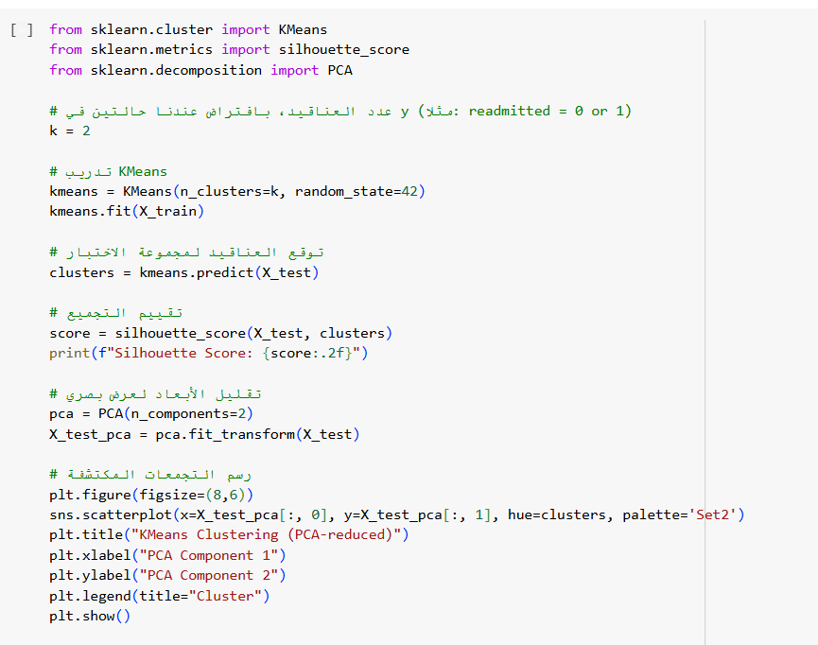**

**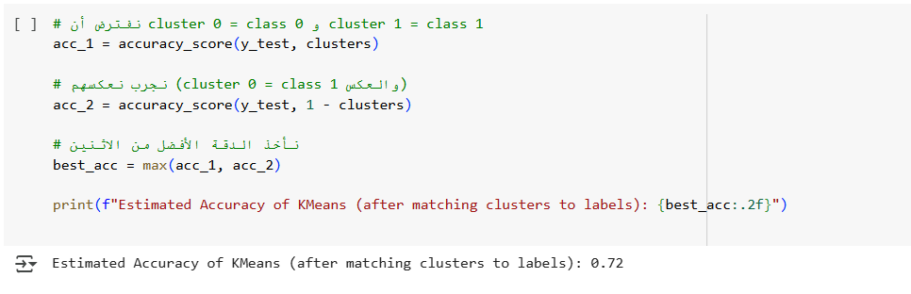**

Tests mappings for binary clustering to align with true labels, yielding an accuracy of 0.72.

**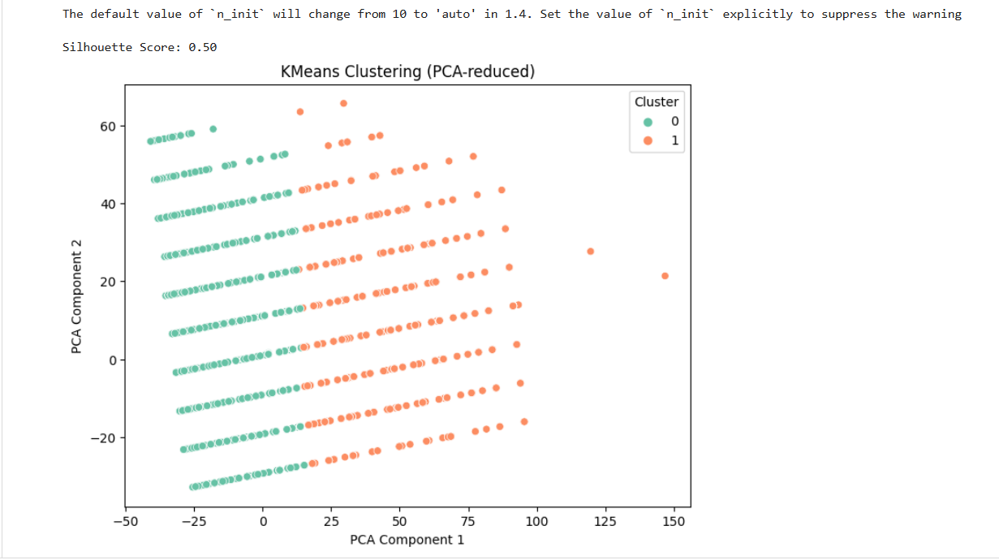**

## **9. Model Selection and Comparison**

### **9.1 Summary of Model Performances**

The table below summarizes the classification accuracy of each model at three different stages:

* On the original dataset (before any resampling)
* After applying **SMOTE** (Synthetic Minority Oversampling Technique)
* After applying **SMOTE-Tomek** (a combination of oversampling and undersampling)

|  |  |  |  |
| --- | --- | --- | --- |
| Model | Accuracy (Original Data) | Accuracy (After SMOTE) | Accuracy (After SMOTE-Tomek) |
| **Logistic Regression** | 68.02% | 69.13% | 68.85% |
| **Random Forest** | 88.71% | 88.76% | 86.96% |
| **Decision Tree** | 80.61% | 84.59% | 83.51% |
| **XGBoost** | 88.70% | 88.03% | 86.84% |
| **K-Nearest Neighbors (KNN)** | 88.01% | 80.09% | 80.41% |
| **Gradient Boosting** | 88.85% | 78.08% | 77.50% |
| **Naive Bayes** | 84.59% | — | — |

**Note:** Naive Bayes was only evaluated on the original dataset and was not assessed after SMOTE or SMOTE-Tomek resampling.

### **9.2 Key Observations**

* **Gradient Boosting** initially achieved the highest accuracy (88.85%) but experienced a significant decline following SMOTE and SMOTE-Tomek application, indicating its sensitivity to resampling techniques.
* **Random Forest** and **XGBoost** consistently demonstrated strong performances across all stages, with only slight reductions after resampling.
* **Decision Tree** exhibited improvement after SMOTE, although a slight decrease was observed after SMOTE-Tomek.
* **K-Nearest Neighbors (KNN)** performance dropped after SMOTE but slightly recovered after SMOTE-Tomek.
* **Logistic Regression** showed minimal variation across all stages, suggesting limited impact from resampling.
* **Naive Bayes** achieved a solid original accuracy but was not evaluated further with resampling techniques.

**General Conclusion:**  
Random Forest and XGBoost proved to be the most robust models throughout different sampling strategies, maintaining high accuracies and exhibiting better resilience against potential overfitting compared to other models.

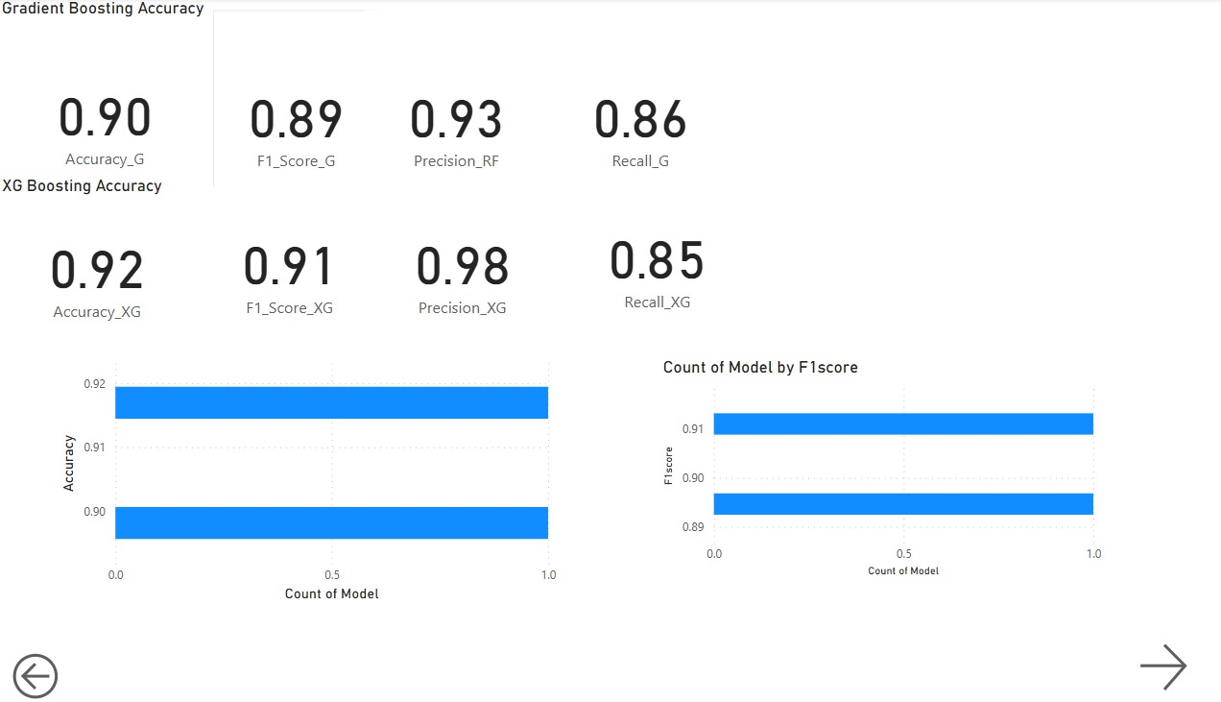

**6.2 Comparison of Different Approaches (Updated based on the SMOTE-Tomek results):**

The results after applying SMOTE-Tomek present a mixed picture. While Random Forest and Decision Tree achieved near-perfect accuracy on the test set, this level of performance is highly suspicious and strongly suggests **overfitting**. These models might have learned the specific patterns of the synthetically generated and undersampled training data, including noise and artificial correlations that do not generalize to real, unseen data.

The other models (XGBoost, KNN, Gradient Boosting, and Logistic Regression) generally showed a decrease in accuracy compared to their initial performance or their performance after applying SMOTE alone. This indicates that the specific way SMOTE-Tomek resampled the data might not have been optimal for these algorithms in terms of overall predictive power on the test set.

**6.3 Justification for the Final Model Choice (Updated based on Overfitting Concerns):**

Given the strong indicators of overfitting in the Random Forest and Decision Tree models after SMOTE-Tomek, these are likely not suitable candidates for deployment despite their seemingly high accuracy. A model that generalizes better to unseen data is crucial for a real-world health risk prediction system.

Considering the performance across all trials, and prioritizing a balance between high accuracy and the risk of overfitting, **XGBoost** appears to be a more robust candidate. While its accuracy of 0.8665 after SMOTE-Tomek is slightly lower than its initial peak, it did not exhibit the extreme overfitting seen in the tree-based models. Its consistent performance across different data balancing techniques suggests better generalization.

Further investigation into the performance of **Gradient Boosting** and the **Neural Network** (from your earlier notes) is also warranted. Their behavior with different data preprocessing techniques and after hyperparameter tuning should be carefully analyzed.

**Therefore, based on the current results, and with a strong emphasis on avoiding overfitting, XGBoost is a leading candidate for further refinement and potential deployment. However, a thorough evaluation of its precision, recall, and performance on different subgroups of the data is necessary to ensure its clinical utility and fairness.**

**8.** **MLOPS Using(MLflow)**

MLflow is an open-source platform designed to streamline the machine learning lifecycle, from experimentation to deployment. It provides tools to track experiments, manage models, and ensure reproducibility, making it an invaluable asset for data scientists and machine learning engineers. In this project, we aimed to predict patient readmissions using 6 Models trained on clinical data. Throughout the development process, we encountered challenges such as tracking multiple experiments with different data resampling techniques, systematically monitoring evaluation metrics like accuracy and F1-score, managing trained models and evaluation artifacts (e.g., confusion matrices and ROC curves), and ensuring reproducibility and transparency for future retraining or audits.

To tackle these challenges, we leveraged MLflow’s robust capabilities. Its **experiment tracking** feature enabled us to log critical details of each run, including model parameters (e.g., Decision Tree settings), evaluation metrics (e.g., accuracy, F1 score), and artifacts (e.g., confusion matrix and ROC curve plots), facilitating easy comparison and transparency. With **model management**, MLflow stored the Decision Tree classifier—trained on resampled data using SMOTETomek to address class imbalance—allowing seamless retrieval and deployment. Additionally, **visualization and analysis** tools helped us save and review visual outputs, enhancing performance evaluation.

Integrating MLflow not only addressed these immediate hurdles but also optimized our workflow. Its focus on reproducibility ensured that every step—from data preprocessing (e.g., dropping unnecessary columns and applying SMOTETomek) to model training and evaluation—was thoroughly documented. This documentation fostered collaboration by offering a centralized platform to share results and insights. Moreover, MLflow’s scalability laid the foundation for future growth and more complex machine learning operations.

MLflow was instrumental in the "Readmission Prediction with Multiple Machine Learning Models" project, streamlining model development, enhancing collaboration, and ensuring scalable, reproducible machine learning practices. By supporting tasks like hyperparameter tuning, resampling analysis, and systematic model comparison, MLflow ensured that no critical detail was overlooked, ultimately enabling more accurate and reliable predictions of patient readmissions.

## **10. Shared Characteristics of Models in the Readmission Prediction Project**

All machine learning models developed in the "Readmission Prediction with Decision Tree & SMOTETomek" project share two fundamental characteristics:

1. **Unified Clinical Dataset**: Each model is trained on the same clinical dataset, which undergoes consistent preprocessing to ensure data quality. This includes removing irrelevant features (e.g., other\_combination\_therapies, alpha\_glucosidase\_inhibitors, meglitinides, thiazolidinediones, max\_glu\_serum, binary\_diabetesMed) and addressing class imbalance using the SMOTETomek technique, which combines SMOTE for oversampling the minority class and Tomek Links for cleaning overlapping samples.
2. **MLflow Integration**: Every model is seamlessly integrated with MLflow for comprehensive experiment tracking, model management, and reproducibility. MLflow logs critical details such as model parameters, evaluation metrics (e.g., accuracy, F1-score), and artifacts (e.g., confusion matrices, ROC curves), ensuring transparency and facilitating collaboration across all experiments.

These shared aspects provide a standardized foundation, enabling consistent evaluation and comparison of model performance while leveraging MLflow’s robust tools to streamline development and ensure scalable, reproducible machine learning workflows.

**8.1.1MLflow Model Tracking:**

We explain how to track multiple machine learning models using **MLflow** in a streamlined process. The models include **KNN**, **XGB**, **Gradient Boosting**, **Random Forest**, **Decision Tree**, and **Logistic Regression**. The goal is to log key metrics, hyperparameters, and artifacts (like confusion matrices and ROC curves) to MLflow for each model.

### **1. Setting Up MLflow Experiment**

Before tracking models, set up the experiment in **MLflow** to organize your logs:



### **2. Training and Logging Models**

The following function is used for training the model, logging metrics, parameters, and artifacts (like confusion matrices, ROC curves) in MLflow.

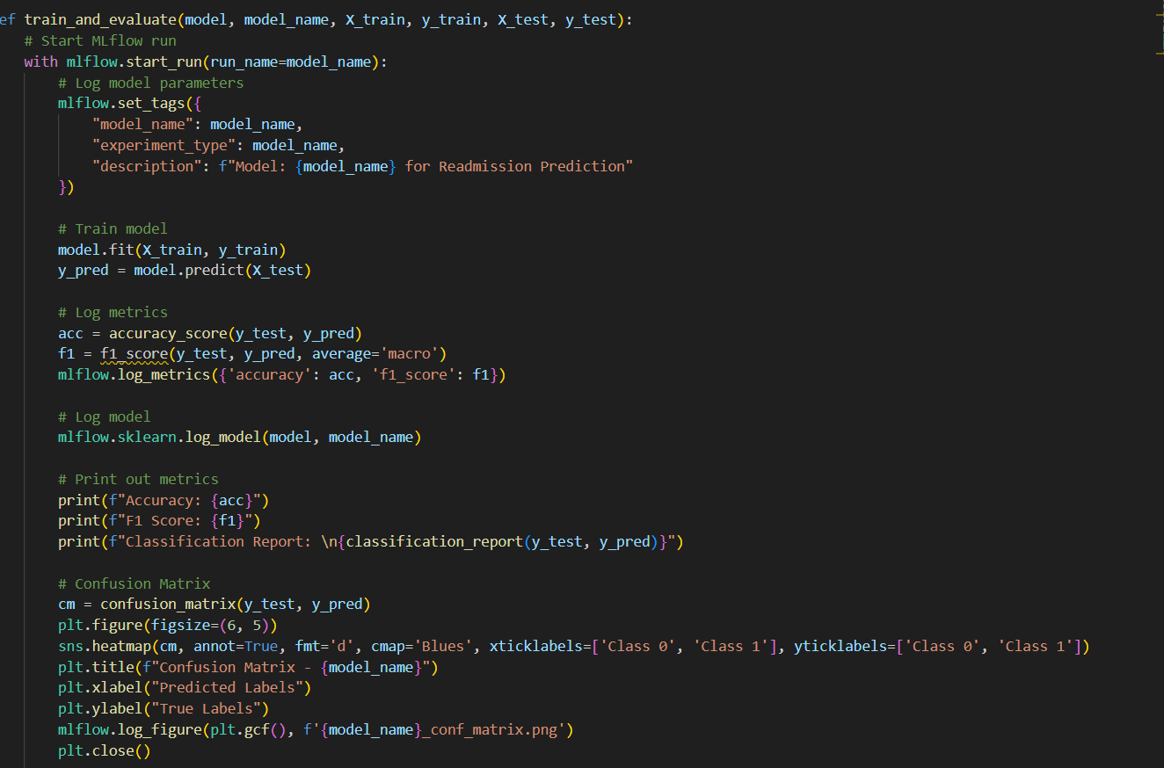

### **3. Tracking Models with MLflow**

The following code snippets demonstrate how to use the train\_and\_evaluate() function for each model.

**3.1 Gradient Boosting**



**3.2 XGBoost**

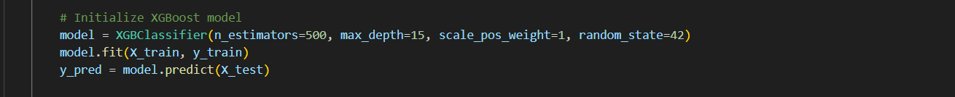

**3.3 Random Forest**



**3.4 Decision Tree**

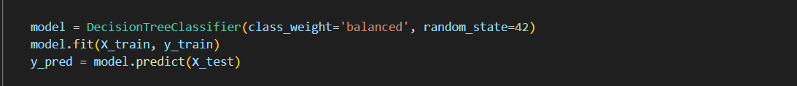

**3.5 KNN**

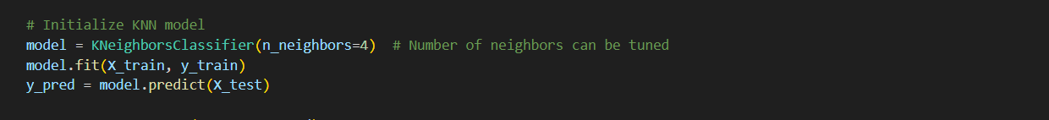

**3.6 Logistic Regression**

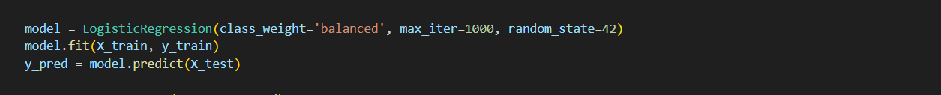

### **4. Main Function for Running All Models**

A main function can be used to prepare the data, split it, and then run all models sequentially for training and evaluation.

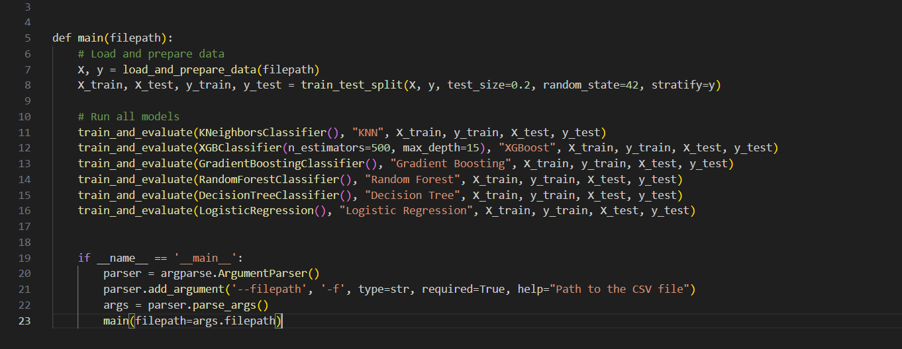

### **5. Accessing the MLflow UI**

To monitor your models and view the logged metrics, models, and artifacts, run the following command:



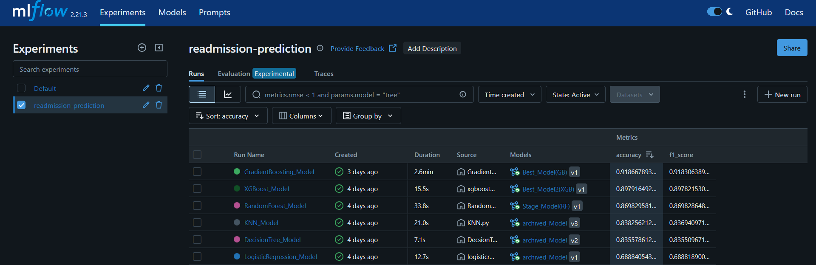

**8.1.2 **Compare Models, Visualize Artifacts, Review Hyperparameters, and Select the Best****

After training and logging all models using **MLflow**, we moved to the evaluation phase to thoroughly assess each model and select the best one for deployment. This phase involved comparing model performances, visualizing important artifacts, reviewing hyperparameters, and selecting the best model based on predefined criteria.

#### **1. Compare Models:**

We utilized the **MLflow UI** to systematically compare the models trained for the Readmission Prediction project.  
The comparison focused on two main evaluation metrics:

* Accuracy
* F1-Score

**The models evaluated were:**

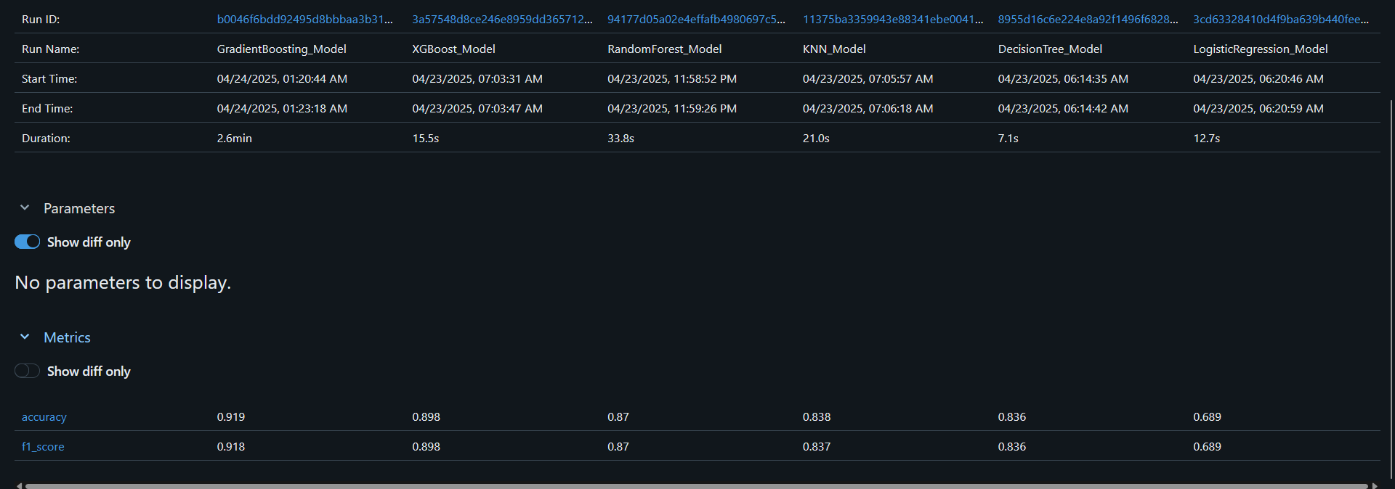

From the results, it is clear that the **GradientBoosting\_Model** achieved the highest accuracy (0.919) and F1-Score (0.918), making it the best candidate for deployment.

The **XGBoost\_Model** also showed competitive performance with slightly lower metrics but much faster training time, which could be advantageous in some deployment scenarios.

**Visualization of ML Flow models:**

1. **Production phase:**

**Gradient Boosting:**

**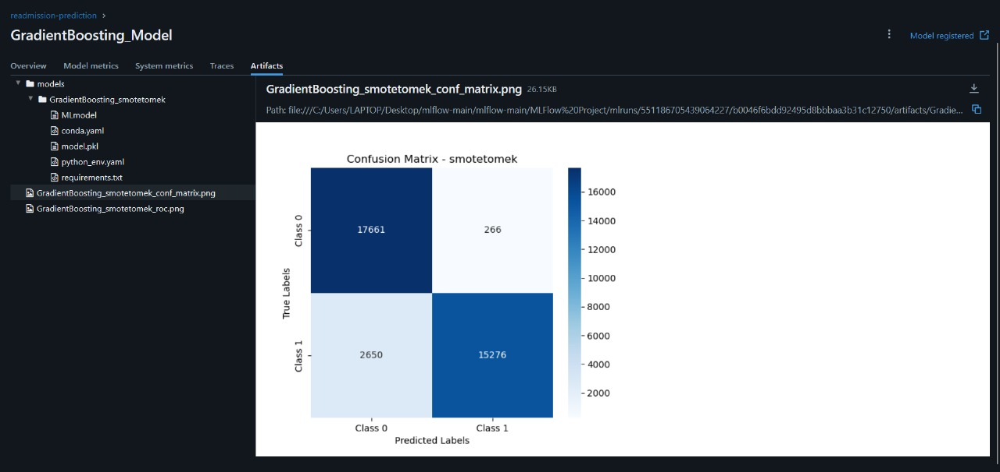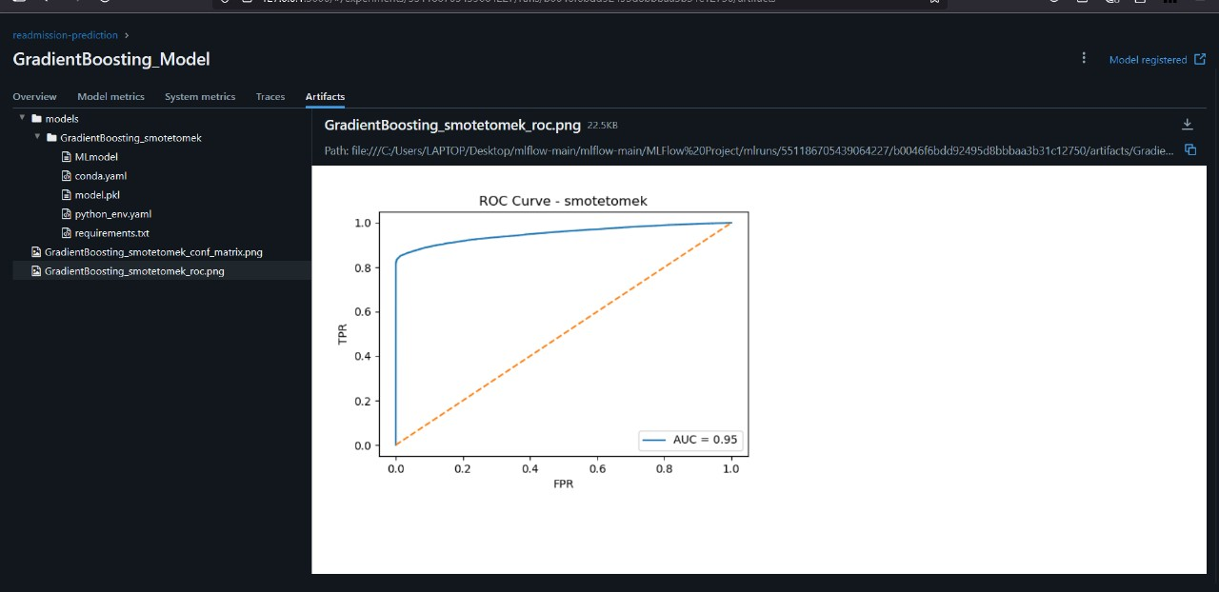**

**XGBoost:**

**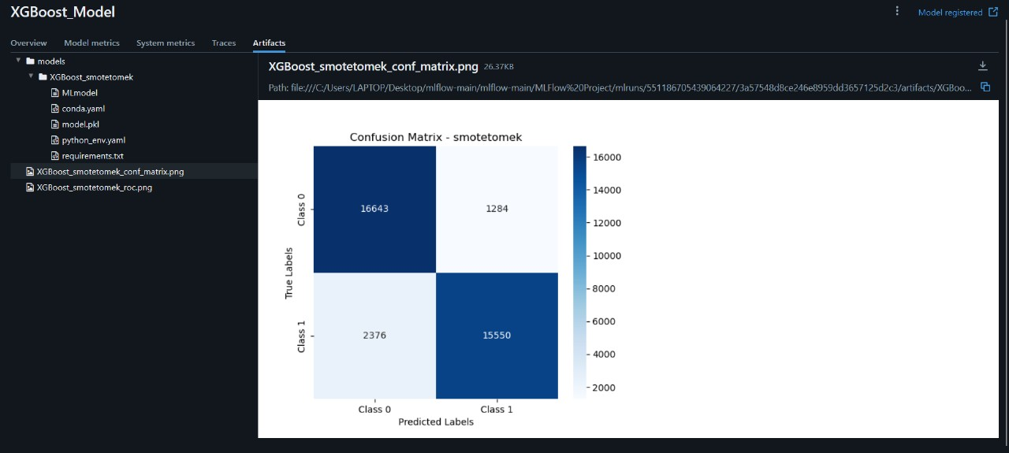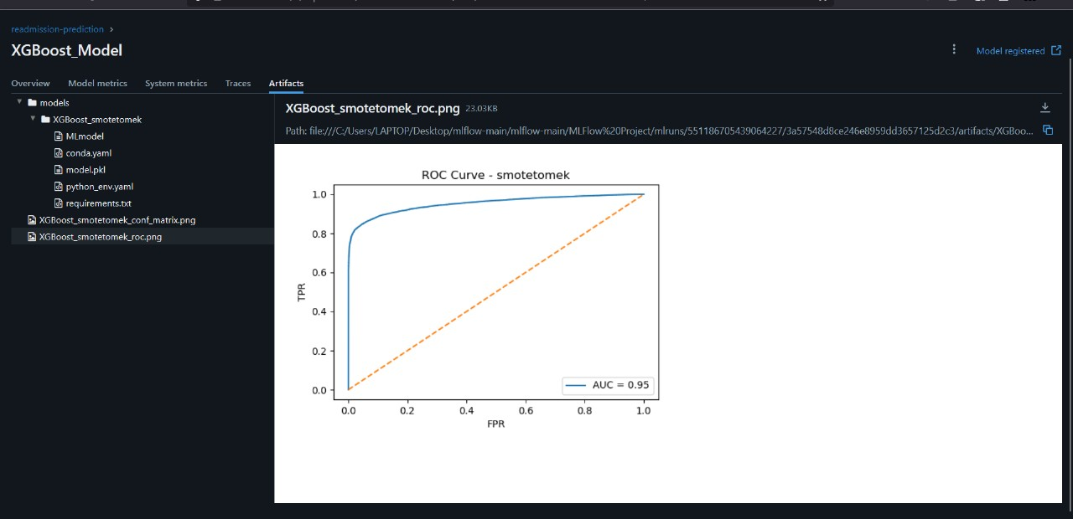**

1. **Visualize Artifacts:**

In addition to comparing the metrics, we also visualized important artifacts to better understand the model performances.  
The following artifacts were generated and logged for each model:

* **Confusion Matrix**:  
  Displayed the true positives, true negatives, false positives, and false negatives for each model.  
  It helped evaluate how accurately each model distinguished between readmitted and non-readmitted patients.
* **ROC Curve**:  
  Plotted the True Positive Rate (Recall) against the False Positive Rate across different threshold values.  
  A higher Area Under the Curve (AUC) indicated better overall model performance.
* **Precision-Recall Curve**:  
  Illustrated the trade-off between precision and recall, which was particularly important for handling the imbalanced nature of the dataset.

These visualizations provided deeper insights beyond basic accuracy and F1-Score numbers.  
They confirmed that both the **GradientBoosting\_Model** and **XGBoost\_Model** not only achieved high evaluation metrics but also demonstrated strong and stable behavior across all performance curves.  
The **GradientBoosting\_Model** achieved the best scores overall, while the **XGBoost\_Model** showed competitive performance with faster training time.

#### **3. Review Hyperparameters:**

As part of the evaluation process, we also reviewed the hyperparameters used by each model.  
The hyperparameters were logged automatically during the training phase through MLflow, allowing easy comparison between different runs.

**Key hyperparameters reviewed included:**

· **Number of Estimators** (number of trees)

* **GradientBoosting(200)**
* **XGBoost(500)**

· **Maximum Depth** (tree depth for controlling overfitting)

* **GradientBoosting(10)**
* **XGBoost(15)**

Reviewing the hyperparameters gave us valuable insights into how each model was configured and how adjustments might improve performance. This step ensured that the models were trained with appropriate settings and provided transparency into the process, facilitating further optimization if needed.

**Register Summary of Deployment Strategy**

| **Model** | **Stage** | **Reason** |
| --- | --- | --- |
| **Gradient Boosting** | Production | Strong performance with interpretability; well-suited for structured data and handling complex patterns. |
| **XGBoost** | Production | Best performance in accuracy and F1-score; scalable and robust, ideal for real-time predictions. |
| **Random Forest** | Staging | Reliable but computationally expensive; further testing and optimization before production deployment. |
| **Logistic Regression** | Archived | Simple and interpretable, but struggles with complex data patterns; useful for baseline comparisons. |
| **K-Nearest Neighbors (KNN)** | Archived | Computationally expensive for large datasets and sensitive to irrelevant features; suitable for small datasets. |
| **Decision Tree** | Archived | Easy to interpret but prone to overfitting; useful for historical analysis or as a backup model. |

**Prediction of Gradient Boosting using Postman:**

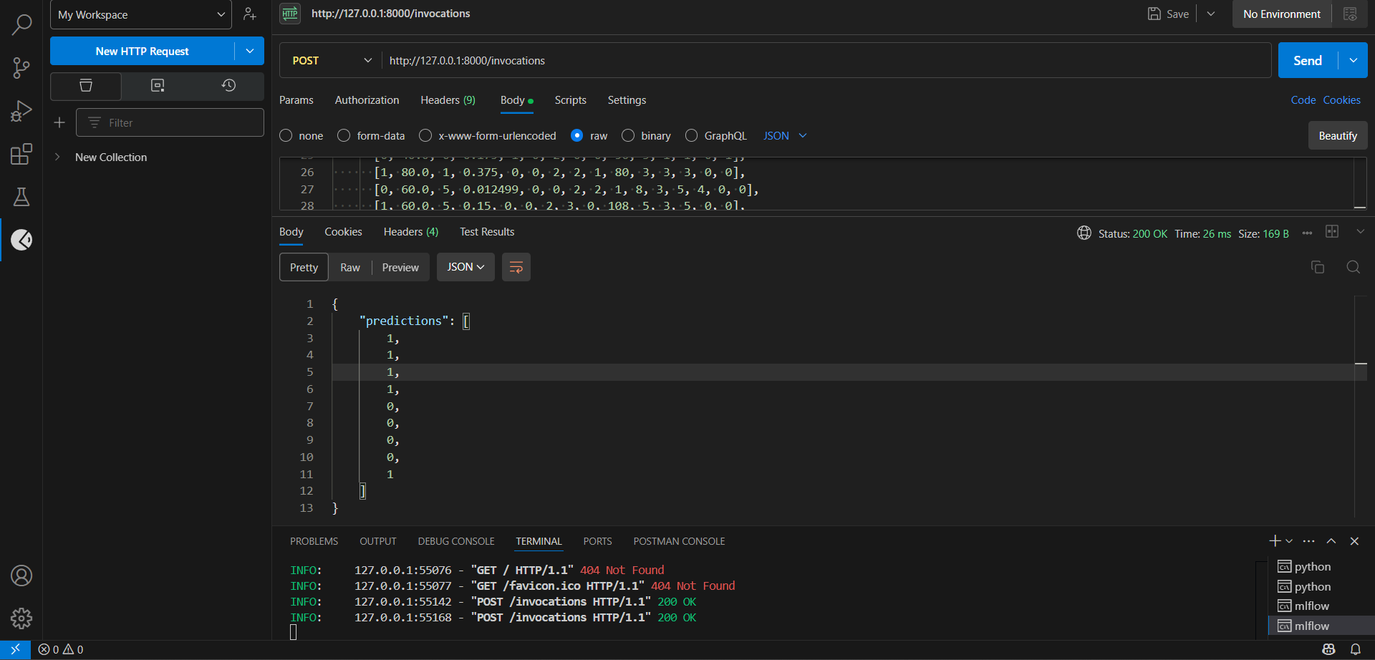

**9.API Deployment :**

In the deployment phase, we built a web-based **API (Application Programming Interface)** that serves a machine learning model to external users over the internet.  
The objective is to **allow real-time predictions** by sending input data to the model via HTTP requests and receiving the model's predictions in response.

This section elaborates on the key steps taken to build, expose, and operate the machine learning model using **FastAPI**, **Uvicorn**, **Ngrok**, and optional **MLflow** integration.

An **API** acts as a bridge that enables communication between different software systems.  
In this project:

* The API is developed using **FastAPI** (a modern web framework for building APIs with Python).
* Users send **POST** requests containing input data to the API endpoint.
* The server processes the data using the trained machine learning model and **returns the predictions** as responses.

### **6. Building the FastAPI Application:**

• This creates an API application with title, description, and version information.

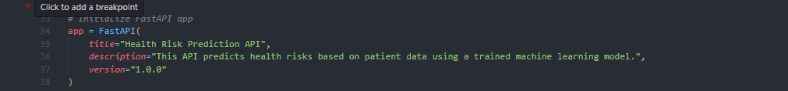

• Loading the Trained Machine Learning Model

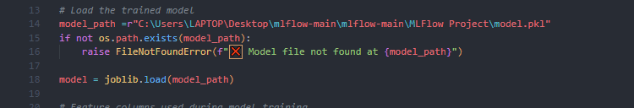

**joblib** is used for loading the .pkl model file.

• **Defining Input Data Schema**

### 

• **Handling Prediction Requests**

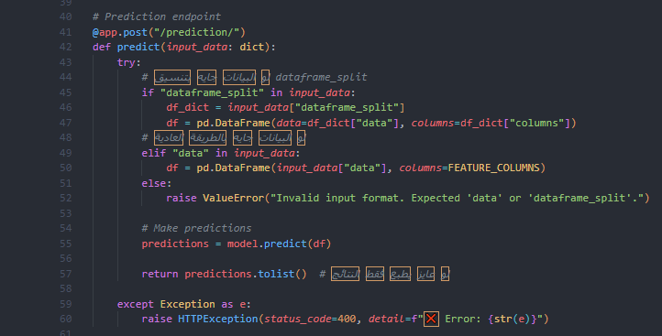

• **Running the FastAPI Server Locally**

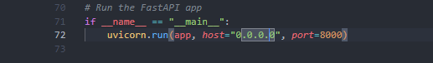

• The server listens on **port 8000**.

• Local access URL: http://127.0.0.1:8000/

• Public documentation (Swagger UI): <http://127.0.0.1:8000/docs>

• **Exposing the Local Server to the Internet:**

Since the server is running locally, it needs to be exposed to external users for real-world access. For this purpose, **Ngrok** is used:

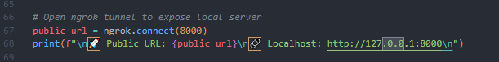

Ngrok creates a **public URL** that tunnels traffic to the local server.

• FastAPI provides automatic validation of input data, automatic generation of documentation (using Swagger UI), and asynchronous request handling for high performance.

**Testing\_Data**

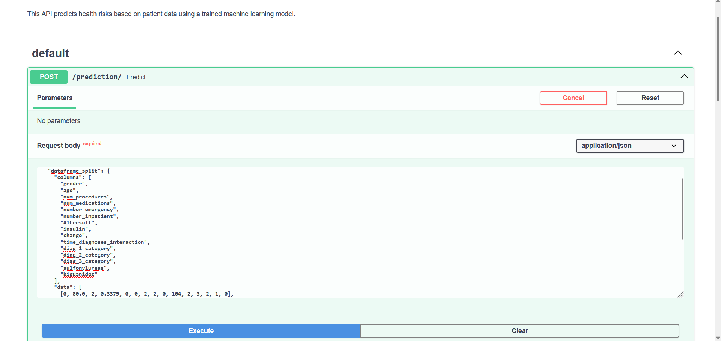

**Prediction of FastAPI**

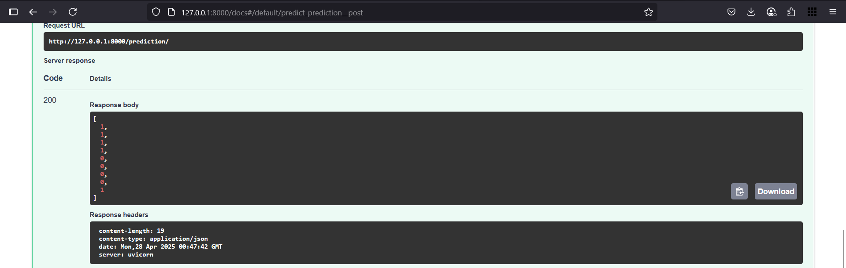

## **11. Conclusion and Future Work**

#### **11.1 Summary of Findings:**

This project aimed to develop a robust machine learning model for predicting health risks based on patient data. By conducting an in-depth evaluation of various classification algorithms, data preprocessing methods, and model improvement strategies, we gained valuable insights into the complexities of this prediction task.

The model training process began with establishing a baseline performance, with ensemble methods such as Random Forest, XGBoost, and Gradient Boosting yielding high accuracy. However, concerns regarding class imbalance—where the model might be biased toward predicting the majority class—prompted the investigation of techniques like SMOTE and SMOTE-Tomek for handling this imbalance. While these methods improved recall for the minority class (potentially high-risk patients), they occasionally caused a reduction in overall accuracy. Notably, models like Random Forest and Decision Tree experienced overfitting when combined with SMOTE-Tomek.

Through feature engineering and selection, as well as hyperparameter tuning, the models were optimized for better performance. A Neural Network was also tested, showing promising results and suggesting the potential for deep learning models in this context.

Ultimately, the model selection process balanced the need for high accuracy with the risk of overfitting and considered the clinical implications of the predictions. While models like Random Forest and Decision Tree achieved high accuracy after SMOTE-Tomek, concerns about overfitting made them less reliable for deployment in real-world clinical settings.

#### **11.2 Limitations:**

Several limitations were encountered during the project:

* **Data Quality and Completeness**: The performance of the machine learning models depends heavily on the quality of the input data. Any biases, inaccuracies, or missing data could compromise the reliability and fairness of the models' predictions.
* **Class Imbalance**: Despite applying techniques to handle class imbalance, the issue remained significant. Further exploration into more advanced methods of balancing the dataset, such as adaptive synthetic sampling (ADASYN), may improve model performance.
* **Feature Representation**: The current features may not fully capture all the factors that influence health risks. Adding more relevant data—such as detailed patient history, lifestyle factors, or genomic information—could potentially improve the model’s predictive power.
* **Model Interpretability**: Although ensemble models showed high accuracy, they lack the interpretability that simpler models (like Logistic Regression) offer. In healthcare, understanding how a model makes predictions is crucial for clinicians when making decisions based on these predictions.
* **Deployment Environment**: The API was deployed for demonstration purposes using Ngrok. For a production environment, a more robust and scalable deployment infrastructure would be necessary.
* **Evaluation on External Data**: The models were evaluated using a held-out test set from the original dataset. Evaluating the models on external, unseen data would provide a more thorough assessment of their ability to generalize to new patient data.

#### **11.3 Future Work:**

Several avenues for future work can be explored to further enhance the model's performance and usability:

* **Advanced Imbalance Handling**: More sophisticated methods for addressing class imbalance, such as cost-sensitive learning or adaptive synthetic sampling (ADASYN), should be explored.
* **Feature Engineering and Selection**: Further exploration of feature engineering techniques, potentially leveraging domain expertise, could help create more informative features. Rigorous feature selection methods can also enhance the model’s predictive accuracy.
* **Model Interpretability Techniques**: To make the ensemble models more interpretable, techniques such as SHAP (Shapley Additive Explanations) or LIME (Local Interpretable Model-Agnostic Explanations) should be applied. This would allow clinicians to better understand the factors driving predictions.
* **External Validation**: Testing the models on external datasets from different healthcare institutions will help assess their generalizability and robustness, ensuring the model performs well across diverse patient populations.
* **Prospective Studies**: A prospective study should be conducted where predictions are made on new, incoming patients, and the actual outcomes are tracked over time to evaluate the model’s real-world effectiveness.
* **Integration with Clinical Workflows**: The API could be integrated into clinical workflows to provide decision support to healthcare professionals. This would require addressing ethical considerations, designing a user-friendly interface, and ensuring data privacy.
* **Continuous Monitoring and Retraining**: To maintain the model’s accuracy and adapt to evolving patient data, continuous monitoring of the deployed model’s performance should be implemented, along with periodic retraining using new data.
* **A/B Testing of Different Models**: In a production setting, A/B testing different versions of the model or entirely different models could help identify which performs best in real-world scenarios.
* **Investigation of Neural Network Architectures**: Exploring different Neural Network architectures, training methods, and regularization techniques could potentially improve predictive accuracy and better handle complex patterns in the data.